STUDENT INTERNSHIP AND PLACEMENT MANAGEMENT SYSTEM
A PROJECT REPORT
Submitted by
SRENITH C N
(2116241501209)
in partial fulfilment of the End Semester Examination for the course

CB23F35 –
LOW-CODE APPLICATION DEVELOPMENT USING ZOHO CREATOR
in
BACHELOR OF TECHNOLOGY
Artificial Intelligence and Machine Learning



RAJALAKSHMI ENGINEERING COLLEGE
(An Autonomous Institution, Affiliated to Anna University, Chennai)
Rajalakshmi Nagar, Thandalam, Tamil Nadu – 602 105
2026-2027

RAJALAKSHMI ENGINEERING COLLEGE
(An Autonomous Institution, Affiliated to Anna University, Chennai)
BONAFIDE CERTIFICATE
Certified that this project report titled “STUDENT INTERNSHIP AND PLACEMENT MANAGEMENT SYSTEM” is the bonafide work of SRENITH C N (2116241501209), who carried out the individual project work on the Zoho Creator low-code platform for the course CB23F35 – Low-Code Application Development using Zoho Creator, during the academic year 2026–2027, Semester V, under my supervision.

SIGNATURE  Dr Ayyadurai M  HEAD OF THE DEPARTMENT  Department of Artificial Intelligence  And Machine Learning  Rajalakshmi Engineering College  Thandalam – 602 105 | SIGNATURE  Ms Priya M  COURSE FACULTY  Assistant Professor  Department of Artificial Intelligence  And Machine Learning  Rajalakshmi Engineering College

Submitted for the End Semester Examination (Individual Project) held on [ ]
INTERNAL EXAMINER | EXTERNAL EXAMINER

DECLARATION

I, SRENITH C N (241501209), hereby declare that the project report “STUDENT INTERNSHIP AND PLACEMENT MANAGEMENT SYSTEM”,
submitted for the End Semester Examination of the course CB23F35 – Low-Code Application Development using Zoho Creator, is a record of the project work carried out by me. The application was configured using Zoho Creator and its AI-assisted builder. Any AI-assisted features, code snippets, templates, or external resources used are to be acknowledged appropriately.
I further declare that this work has not been submitted, in part or in full, for the award of any other degree or course credit.

Place: Chennai SIGNATURE OF THE STUDENT
Date: 19 October 2026 SRENITH C N
241501209

ACKNOWLEDGEMENT

I express my sincere gratitude to the management of Rajalakshmi Engineering College, including Chairperson Dr. (Mrs.) Thangam Meganathan, Chairman Mr. S. Meganathan, Vice Chairman Mr. Abhay Shankar Meganathan, and the college administration, for providing the infrastructure and facilities required for this project.
I express my sincere gratitude to the Principal, Dr. S. N. Murugesan, for providing encouragement and support for academic learning and project work.
I express my gratitude to the Head of the Department, Dr. Ayyadurai M, Department of Artificial Intelligence and Machine Learning, for the academic guidance and support provided during the course.
I sincerely thank my course faculty, Mrs. Priya M, for the guidance and feedback provided throughout the development of this application and preparation of this report.
I also acknowledge Zoho Creator and its learning resources for providing a low-code environment in which the application could be configured. Finally, I thank my family and friends for their support.

SRENITH C N

ABSTRACT
Student internship and placement activities involve students, companies, internship opportunities, job openings, applications, interviews, offers, and internship completion records. When these activities are handled through separate spreadsheets or informal communication, information can become fragmented, duplicate entries may occur, application statuses can be difficult to track, and preparing summaries may require repeated manual effort. The Student Internship and Placement Management System was developed as a low-code application using Zoho Creator to provide a central place to record and review these activities. The intended users include placement staff and other authorised users who maintain student and employer information and coordinate recruitment activities.

The application contains forms for student registration, company registration, internship opportunities, job openings, internship applications, placement applications, interview schedules, placement offers, and internship completion. Reports were created to display the main records, and a dashboard was configured with six summary cards and three pie charts. Eight-plus workflows were reported as created and enabled by the Zoho Creator Zia Build Agent, including default-status workflows and validation workflows for internship applications, placement applications, and placement offers. The validation scripts and field mappings must be checked in the live application and tested with actual records before their behaviour is treated as verified. No external integration, production deployment, or role-based access configuration is claimed in this report unless later confirmed with evidence.

Development was carried out through the Zoho Creator application builder and its AI-assisted configuration facilities. The current build has been reported to contain the main forms, reports, dashboard, and workflows. The next validation step is end-to-end manual testing: adding sample records, confirming that related records appear in reports, testing duplicate application prevention and invalid salary rejection, and checking that dashboard values update from saved data. Actual performance measurements and user-acceptance results have not yet been collected; therefore, quantitative improvements are not claimed. The application provides a practical foundation for centralised internship and placement record management and can be

extended with role-based access, notifications, deadline reminders, and verified deployment controls.

Keywords: Low-Code Development; Zoho Creator; Student Placement; Internship Management; Workflow Automation; Deluge Scripting.

PROJECT AT A GLANCE

Attribute | Details
Project Title | Student Internship and Placement Management System
Application Domain | Education / Campus Recruitment
Student Name & Register No. | SRENITH C N – 241501209
Zoho Creator Edition | Student Edition
Application Name (Link Name) | student-internship-placement-  management-system
Published / Live URL | https://creatorapp.zohopublic.in/ srenith.cn.2024.aiml_raja275/student-internship-placement-management-system/form-perma/ Company_Registration_Form/ WHrrXzCswvyDnP5g30HfS2Jux6KWd rWVyGKMFSMRMQ20nfhkAmvzYzA fp3F58x62hYdGSn5rn3HhjsJV7H3zpky  h8VTyQvadXTNA
Demo Credentials | Not included in this report.
Number of Forms / Subforms | 9 main forms
Number of Reports (by type) | 9 reports
Number of Pages / Dashboards | 1 dashboard:  Student_Placement_Dashboard
Number of Workflows | 9 workflows
Deluge Functions / Custom Actions | 3 validation workflows
Integrations | No external integrations configured
Roles & Profiles Defined | Administrator / placement-management  stakeholders
Environments Used | Zoho Creator Student Edition
Date of Production Deployment | Public Company Registration Form link available; formal deployment date not  recorded

TABLE OF CONTENTS
ABSTRACT v
PROJECT AT A GLANCE vi
LIST OF TABLES x
LIST OF FIGURES xi
LIST OF ABBREVIATIONS xii
INTRODUCTION 1
1.1 Background 1
1.2 Problem Statement 1
1.3 Objectives……………………………………………………………………….2
1.4 Scope of the Project 2
1.5 Justification for a Low-Code Approach 2
1.6 Organisation of the Report 3
LITERATURE SURVEY AND SYSTEM STUDY 4
2.1 Study of the Existing System 4
2.2 Limitations of the Existing System 4
2.3 Low-Code versus Traditional Development 5
2.4 Literature Survey 5
2.5 Emerging Trends in Low-Code Development 6
2.6 Proposed System 6
REQUIREMENT ANALYSIS 7
3.1 Stakeholders and User Roles 7
3.2 Functional Requirements 7
3.3 Non-Functional Requirements 9
3.4 Hardware and Software Requirements…………………………………………10
3.5 Use Case Model ………………………………………………………………10
SYSTEM DESIGN 12
4.1 System Architecture 12
4.2 Data Model 13
4.3 Form Design 14
4.4 Process and Workflow Design 16
4.5 User Interface and Navigation Design 16
4.6 Access Control Design 17
IMPLEMENTATION 19
5.1 Application Setup 19
5.2 Forms and Data Capture 19
5.3 Reports 21
5.4 Pages and Dashboards 22
5.5 Deluge Scripting 23
5.6 Workflows and Automation 25
5.7 Integrations 28
5.8 User Management and Role-Based Access 29
5.9 AI and Analytics Features 30
5.10 Pro-Code Extension 30
5.11 Mobile and Portal Access 31
TESTING AND DEBUGGING 32
6.1 Testing Strategy 32
6.2 Test Cases 32
6.3 Debugging Deluge Scripts 35
6.4 Defect Log 36
6.5 User Acceptance Testing 36
DEPLOYMENT, SECURITY AND GOVERNANCE 37
7.1 Environments and Deployment Strategy 37
7.2 Performance Optimisation 38
7.3 Security Features 39
7.4 Governance and Administration 39
RESULTS AND DISCUSSION 41
8.1 Application Output 41
8.2 Achievement of Objectives 42
8.3 Comparison with the Existing System 43
8.4 Limitations of the Low-Code Approach 44
8.5 Reflection on the No-Code → Low-Code → Pro-Code Spectrum 44
CONCLUSION AND FUTURE ENHANCEMENTS 45
9.1 Conclusion 45
9.2 Future Enhancements 45
9.3 Learning Outcomes and Career Relevance 46
REFERENCES 47
APPENDIX A – ZOHO CREATOR FEATURE COVERAGE CHECKLIST 48
APPENDIX B – COURSE OUTCOME MAPPING 52
APPENDIX C – COMPLETE DELUGE SOURCE CODE 54
APPENDIX D – USER MANUAL 55
D.1 Accessing the Application 55
D.2 Instructions for IT Staff 56
D.3 Instructions for Employees and Managers 55
APPENDIX E – EVALUATION RUBRIC 56
APPENDIX F – VIVA-VOCE RECORD SHEET 56

LIST OF TABLES

Table 2.1: Comparison of Low-Code and Traditional Development Table 2.2: Summary of Literature Survey
Table 3.1: Stakeholders and User Roles Table 3.2: Functional Requirements Table 3.3: Non-Functional Requirements
Table 3.4: Hardware and Software Requirements Table 3.5: Use Case Description
Table 4.1: Entities and Relationships
Table 4.2: Form Field Specification Summary Table 4.3: Role–Permission Matrix
Table 5.1: Reports Implemented
Table 5.2: Deluge Scripts Implemented Table 5.3: Workflows Implemented Table 5.4: Integrations Implemented Table 6.1: Test Cases
Table 6.2: Defect Log
Table 6.3: User Acceptance Feedback Table 7.1: Deployment Checklist
Table 7.2: Performance Optimisation Results Table 7.3: Security Controls Implemented Table 8.1: Mapping of Objectives to Outcomes
Table 8.2: Existing System versus Proposed Application
Table A.1: Feature Coverage Checklist Table B.1: Course Outcome Mapping

LIST OF FIGURES
Figure 2.1: As-Is Process Flow of the Existing System Figure 3.1: Use Case Diagram of the Application Figure 4.1: System Architecture
Figure 4.2: Entity–Relationship Diagram Figure 4.3: Application Workflow
Figure 4.4: Navigation Structure and Dashboard Wireframe

Figure 5.1: Application Home and Navigation Sections
Figure 5.2: Form Builder Screenshot
Figure 5.3: Live Form Screenshot
Figure 5.4: Report Screenshot
Figure 5.5: Student Placement Dashboard
Figure 5.6: Workflow Configuration
Figure 5.7: Integration Setup (Not Implemented / Not Applicable) Figure 5.8: Roles and Permission Profiles (If configured)
Figure 5.9: Zia / Analytics Feature

Figure 5.10: Mobile / Portal Access (If used) Figure 6.1: Deluge Debug Output
Figure 7.1: Deployment / Publish Settings Figure 7.2: Audit Trail / Administration Settings Figure 8.1–8.3: End-to-End Test Scenario

LIST OF ABBREVIATIONS

Abbreviation | Expansion
API | Application Programming Interface
CRUD | Create, Read, Update, Delete
ER | Entity–Relationship
JSON | JavaScript Object Notation
LCAP | Low-Code Application Platform
RBAC | Role-Based Access Control
REST | Representational State Transfer
SDLC | Software Development Life Cycle
UAT | User Acceptance Testing
UI | User Interface
Zia | Zoho's AI assistant
Deluge | Data Enriched Language for the Universal Grid Environment

CHAPTER 1 INTRODUCTION
  - Background
Internship and placement coordination is an important activity in an engineering college. It involves maintaining student profiles, company details, internship opportunities, job openings, applications, interview schedules, offers, and internship completion records. These activities are connected: a student applies to an opportunity, the application is reviewed, interviews may be scheduled, an offer may be issued, and an internship may later be marked complete.
When information is maintained in separate spreadsheets, documents, and messages, staff may need to search multiple locations to answer simple questions such as which students applied to a role, which interviews are upcoming, or which offers have been accepted. A centralised application can provide structured data entry, searchable reports, status fields, and a dashboard for quick overview.
This project uses Zoho Creator, a low-code application platform, to build a Student Internship and Placement Management System. The application was configured with forms, reports, a dashboard, and record-creation workflows. The project focuses on a simple working prototype rather than claiming a fully integrated enterprise recruitment platform.
  - Problem Statement
The problem addressed is the lack of a single structured place to maintain and review internship and placement information from student registration through applications, interviews, offers, and internship completion. Disconnected manual records can create duplicated data, inconsistent statuses, delayed searches, and difficulty preparing current summaries.
- Student, company, opportunity, and application details may be scattered across multiple files or messages.
- Duplicate applications or incomplete records may not be detected consistently without validation.
- Upcoming interviews and application statuses may require manual follow-up.

- Preparing summaries for students, companies, applications, and offers can require repeated manual work.
- Without verified access permissions, private student information may be visible to users who should not access it.
  - Objectives
- To create structured forms for students, companies, internship opportunities, and job openings.
- To record and track internship and placement applications using status fields.
- To maintain interview schedules, placement offers, and internship completion records.
- To create reports that allow users to view records by module.
- To provide a dashboard with summary cards and charts based on application data.
- To configure simple workflows and validation rules, then test them using actual records.
  - Scope of the Project
In scope: student and company registration; internship and job opportunity management; internship and placement applications; interview scheduling; placement offers; internship completion; reports; a summary dashboard; default-status workflows; and validation logic reported by the builder.
Out of scope in the current build unless separately configured: external job-board integration, email/SMS notifications, payment processing, predictive candidate ranking, production deployment across separate environments, verified role-based record restrictions, and a student self-service portal. The existence of forms and workflows does not by itself prove these advanced features are available or enabled.
  - Justification for a Low-Code Approach
Zoho Creator was selected because the application is mainly a record-management workflow. Forms, lookup fields, reports, dashboard components, and workflow rules can be configured through a visual builder, while Deluge can support custom validation logic. This reduces the amount of application infrastructure that must be written manually and makes routine changes easier to maintain. The choice is

appropriate for a student prototype, although platform limits and the need to verify generated scripts remain important.
Zoho Creator's official documentation and Deluge reference are used as technical starting points [1], [2].
  - Organisation of the Report
Chapter 2 studies the existing process and low-code approach. Chapter 3 presents stakeholders and requirements. Chapter 4 describes architecture, data entities, forms, workflows, navigation, and access control design. Chapter 5 documents the configured application. Chapter 6 defines testing and debugging. Chapter 7 discusses deployment, security, and governance. Chapter 8 reviews outcomes and limitations. Chapter 9 concludes the work and lists future enhancements.

CHAPTER 2
LITERATURE SURVEY AND SYSTEM STUDY

  - Study of the Existing System
A typical manual workflow begins when student information is collected, followed by the recording of companies and available opportunities. Students apply for internships or jobs, and staff review applications and coordinate interviews. Selection outcomes are then communicated and offers are tracked. Internship completion details and certificates are recorded later. In a spreadsheet-based process, these steps can be stored in different files and updated by different people.

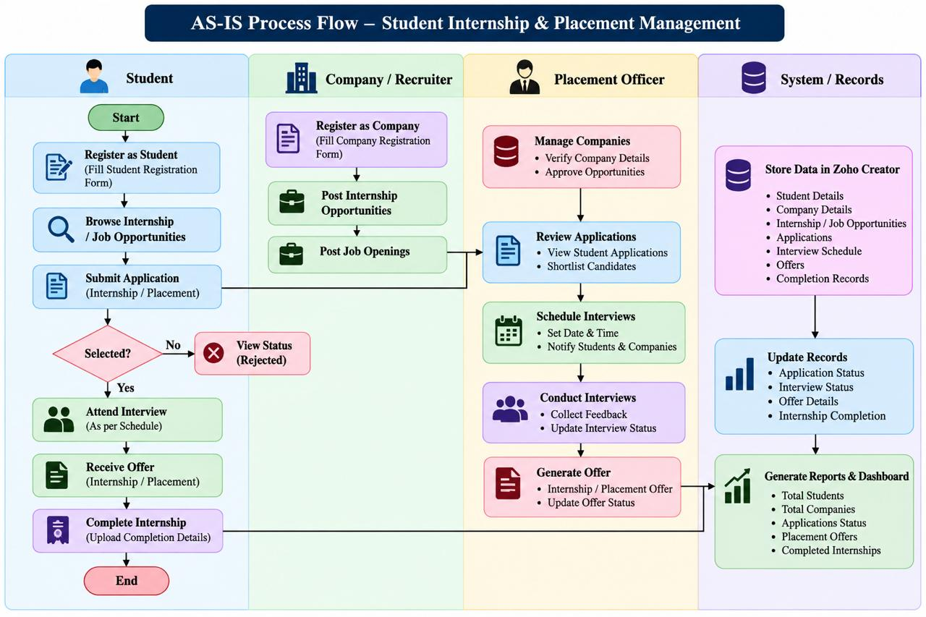

Figure 2.1: As-Is Process Flow of the Existing System (replace with a simple flow diagram)

  - Limitations of the Existing System
- Data is fragmented across separate files and communication channels.
- Searching and preparing reports can require manual consolidation.
- Status changes may not be reflected consistently in all copies of a record.
- Duplicate applications and invalid values may pass without specific checks.
- A manual process makes it harder to view a consolidated dashboard.

2.3 Low-Code versus Traditional Development
Table 2.1: Comparison of Low-Code and Traditional Development

Criterion | Traditional (Pro-Code) Development | Low-Code on Zoho Creator
Development effort | Requires coding of data model, UI, server logic, deployment and maintenance. | Forms, reports, menus and workflows can be configured visually; custom logic may use Deluge.
Skills required | Programming, database, frontend, backend and deployment skills. | Platform configuration skills and Deluge knowledge for advanced logic.
Hosting and infrastructure | Must be selected and managed by the development team. | Platform-hosted runtime is provided by Zoho Creator, subject to the account plan.
Reporting | Reports and dashboards are developed or integrated separately. | Built-in report and dashboard builders are available.
Maintenance | Changes may require code updates and redeployment. | Many field, report and workflow changes can be made in the builder.

Customisation | High flexibility, with higher implementation effort. | Convenient within platform capabilities; specialised UI or logic may require extensions.
Cost | Depends on development effort and infrastructure. | Depends on the Creator edition, usage and implementation requirements.

  - Literature Survey
The following sources provide platform documentation and background for the implementation. The report does not claim a systematic academic review of five research papers; add verified papers from the college library if the course faculty requires a research-focused survey.
Table 2.2: Summary of Literature Survey

S.No. | Source / Year | Title / Product | Key Focus | Relevance
1 | Zoho Corporation | Zoho Creator Help Documentation | Forms, reports, pages and application configuration. | Primary platform guidance for building the application.
2 | Zoho Corporation | Deluge Script Reference | Deluge syntax, conditions and data operations. | Reference for validation and workflow logic.
3 | Zoho Corporation | Zoho Creator Resources | Learning material and product capabilities. | Supports understanding of low-code features.
4 | Zoho Corporation | Zoho Creator Workflow documentation | Record events and workflow actions. | Relevant to status-setting automation.
5 | Zoho Corporation | Zoho Creator security / permissions documentation | User permissions and access configuration. | Relevant to protecting student and placement records.

  - Emerging Trends in Low-Code Development
Low-code platforms increasingly combine visual application design with reusable components, workflow automation, analytics, and AI-assisted configuration. In this project, the Zia Build Agent was used to help configure forms, reports, dashboard components, and workflows. Generated configuration should still be inspected and tested; an AI-generated workflow description is not sufficient evidence that the underlying Deluge logic enforces the intended rule.
  - Proposed System
The proposed system consolidates core internship and placement records in one Zoho Creator application. Its nine forms support data capture, nine reports provide record views, and the Student Placement Dashboard provides six summary cards and three pie charts. Record-creation workflows set default statuses, while three validation workflows were reported to contain custom logic for internship applications,
placement applications, and placement offers. End-to-end tests are still required to confirm relationships, duplicate prevention, salary validation, and chart calculations.

CHAPTER 3 REQUIREMENT ANALYSIS
  - Stakeholders and User Roles
Table 3.1: Stakeholders and User Roles

Role | Description | Key Responsibilities
Administrator / App Owner | Maintains the Creator application. | Manage forms, reports, workflows, and configuration.
Placement Officer | Coordinates campus recruitment records. | Maintain students, companies, opportunities, applications, interviews, and offers.
Recruiter / Company Contact | Provides recruitment-related information where access is granted. | Review assigned applications and provide interview feedback, if access is configured.
Student | Person whose details and applications are stored. | Student self-service access is a future enhancement unless a portal and permissions are configured.

The roles above describe the intended stakeholders. Actual Zoho Creator user roles and record-level restrictions have not been confirmed and must not be assumed from the menu sections alone.
Functional Requirements
Table 3.2: Functional Requirements

FR ID | Requirement | Role(s) | Priority
FR-01 | The system shall capture student registration records. | Placement Officer / Administrator | High
FR-02 | The system shall capture company details. | Placement Officer / Administrator | High
FR-03 | The system shall store internship opportunities and job openings. | Placement Officer / Administrator | High
FR-04 | The system shall record internship applications and their statuses. | Placement Officer / Administrator | High
FR-05 | The system shall record placement applications and their statuses. | Placement Officer / Administrator | High
FR-06 | The system shall store interview dates, times, modes, and statuses. | Placement Officer / Administrator | High
FR-07 | The system shall record placement offers and offer statuses. | Placement Officer / Administrator | High
FR-08 | The system shall record internship completion and certificate details. | Placement Officer / Administrator | Medium
FR-09 | The system shall provide reports for the main record types. | Authorised users | High
FR-10 | The dashboard shall display summary cards and charts from stored data. | Authorised users | Medium
FR-11 | Workflows shall set default statuses on record creation. | Application administrator | Medium
FR-12 | Validation logic shall reject configured invalid application or offer records. | Application administrator / users | High

3.3 Non-Functional Requirements
Table 3.3: Non-Functional Requirements

NFR ID | Category | Requirement
NFR-01 | Usability | Forms and reports should be understandable and easy to navigate.
NFR-02 | Data integrity | Required fields, dropdown values and validation logic should reduce incomplete or invalid records.
NFR-03 | Performance | Reports and dashboard components should load within an acceptable time; measure this during testing.
NFR-04 | Security | Only authorised users should access private student records; permissions must be configured and tested.
NFR-05 | Maintainability | Form, report and workflow names should be consistent and changes documented.
NFR-06 | Availability | The application should be accessible when the Zoho Creator service and user connection are available.
NFR-07 | Auditability | Record changes and workflow outcomes should be reviewed using available platform logs where configured.

3.4 Hardware and Software Requirements
Table 3.4: Hardware and Software Requirements

Category | Specification
Platform | Zoho Creator (edition to be confirmed from account settings)
Scripting | Deluge for custom workflow and validation logic, where used
Browser | Current version of a supported web browser
Client hardware | Laptop or desktop with internet connectivity
Additional tools | Zoho Creator Zia Build Agent was used for assisted configuration
External services | No API or external integration confirmed in the  current build

3.5 Use Case Model

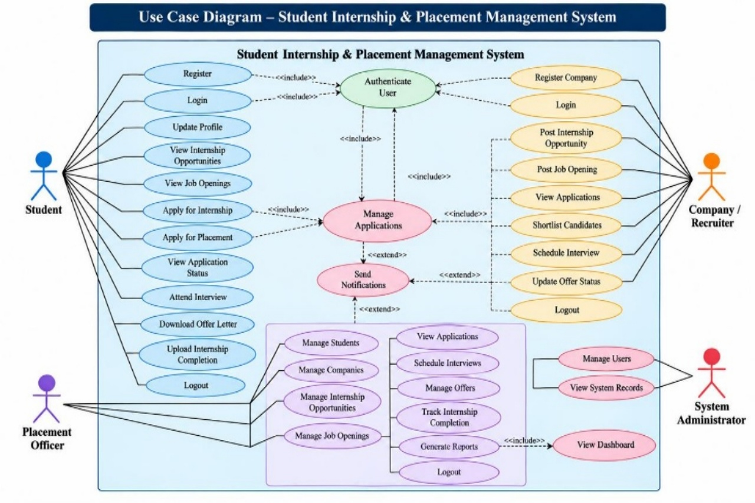

Figure 3.1: Use Case Diagram of the Application

Item | Description
Use Case ID | UC-01
Use Case Name | Record an Internship Application
Actor(s) | Placement Officer / authorised application user
Pre-condition | Student and internship opportunity records are available.
Main Flow | 1. Open Internship_Application_Form. 2. Select the student and internship opportunity. 3. Enter application date and upload resume if required. 4. Submit the form. 5. Check the Internship_Applications report.
Alternate Flow | If validation is configured and detects a duplicate or closed opportunity, submission should be rejected with a message. This behaviour must be tested.
Post-condition | A valid application record should be saved and visible in the corresponding report.
Related FR | FR-04, FR-09, FR-12
Table 3.5: Use Case Description – Record an Internship Application

CHAPTER 4 SYSTEM DESIGN

  - System Architecture
The application follows a platform-hosted low-code architecture. An authorised user accesses the Zoho Creator application through a web browser. The application layer contains forms, reports, dashboard components, and workflows. Data entered through forms is stored in the Creator application's data layer. Workflows run on configured record events. No separate external API layer is included in the current design because no integration has been confirmed.

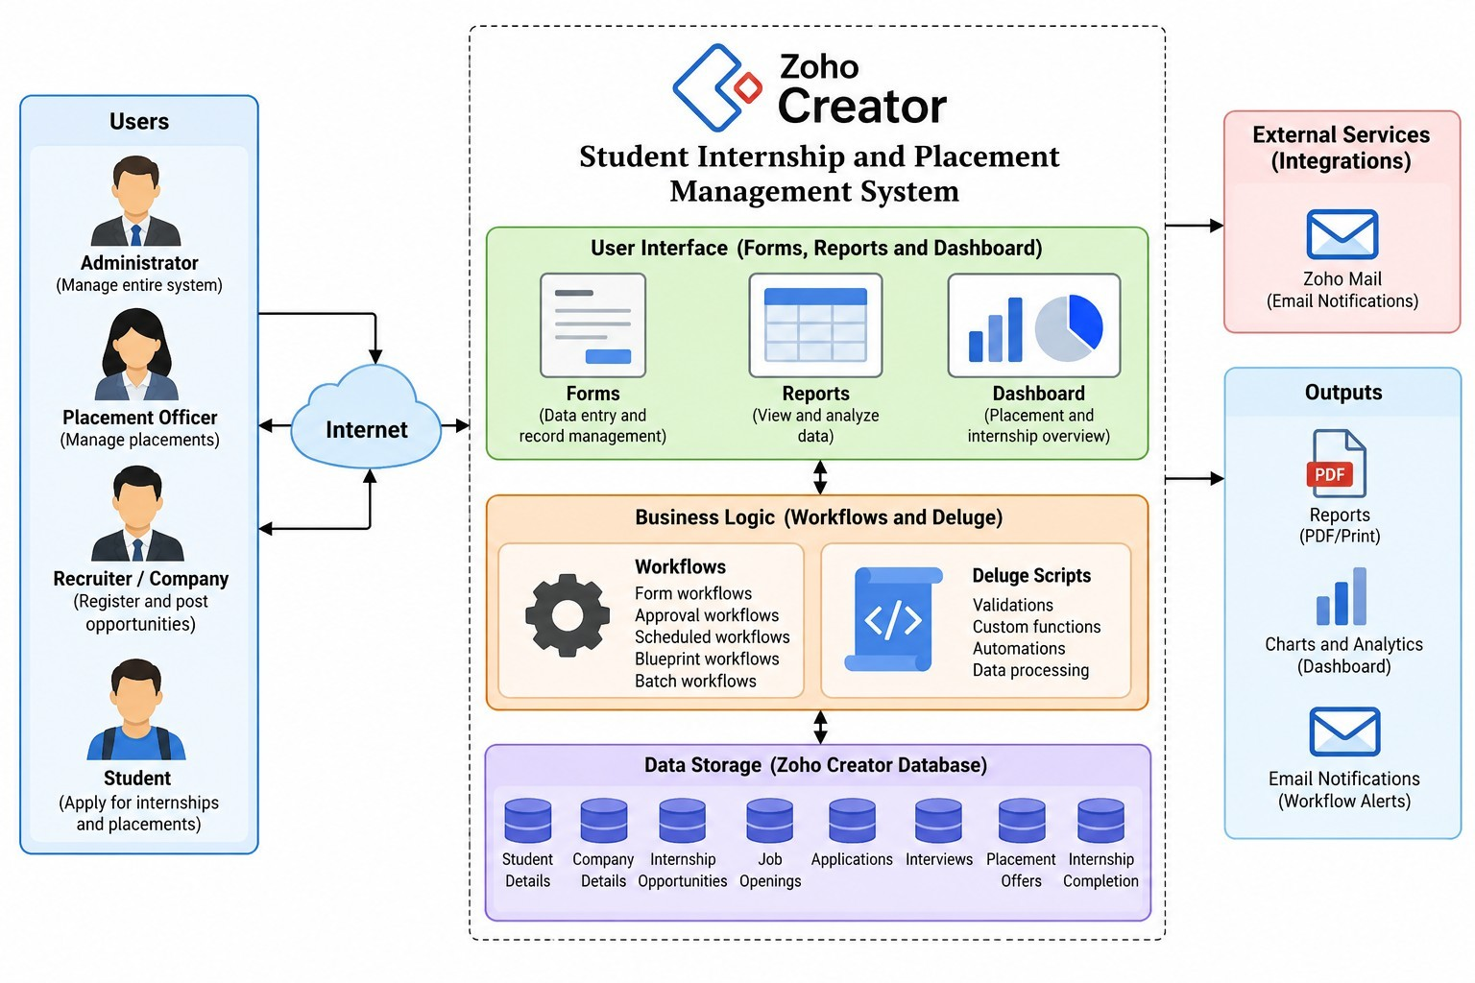

Figure 4.1: System Architecture of the Application

  - Data Model
The main entities are Student, Company, Internship Opportunity, Job Opening, Internship Application, Placement Application, Interview Schedule, Placement Offer, and Internship Completion. The intended relationships connect applications to students and opportunities, interviews to the relevant candidate and recruitment activity, offers to a student and job application, and completion records to an internship application. The actual implementation of each lookup must be checked in the live form builder.

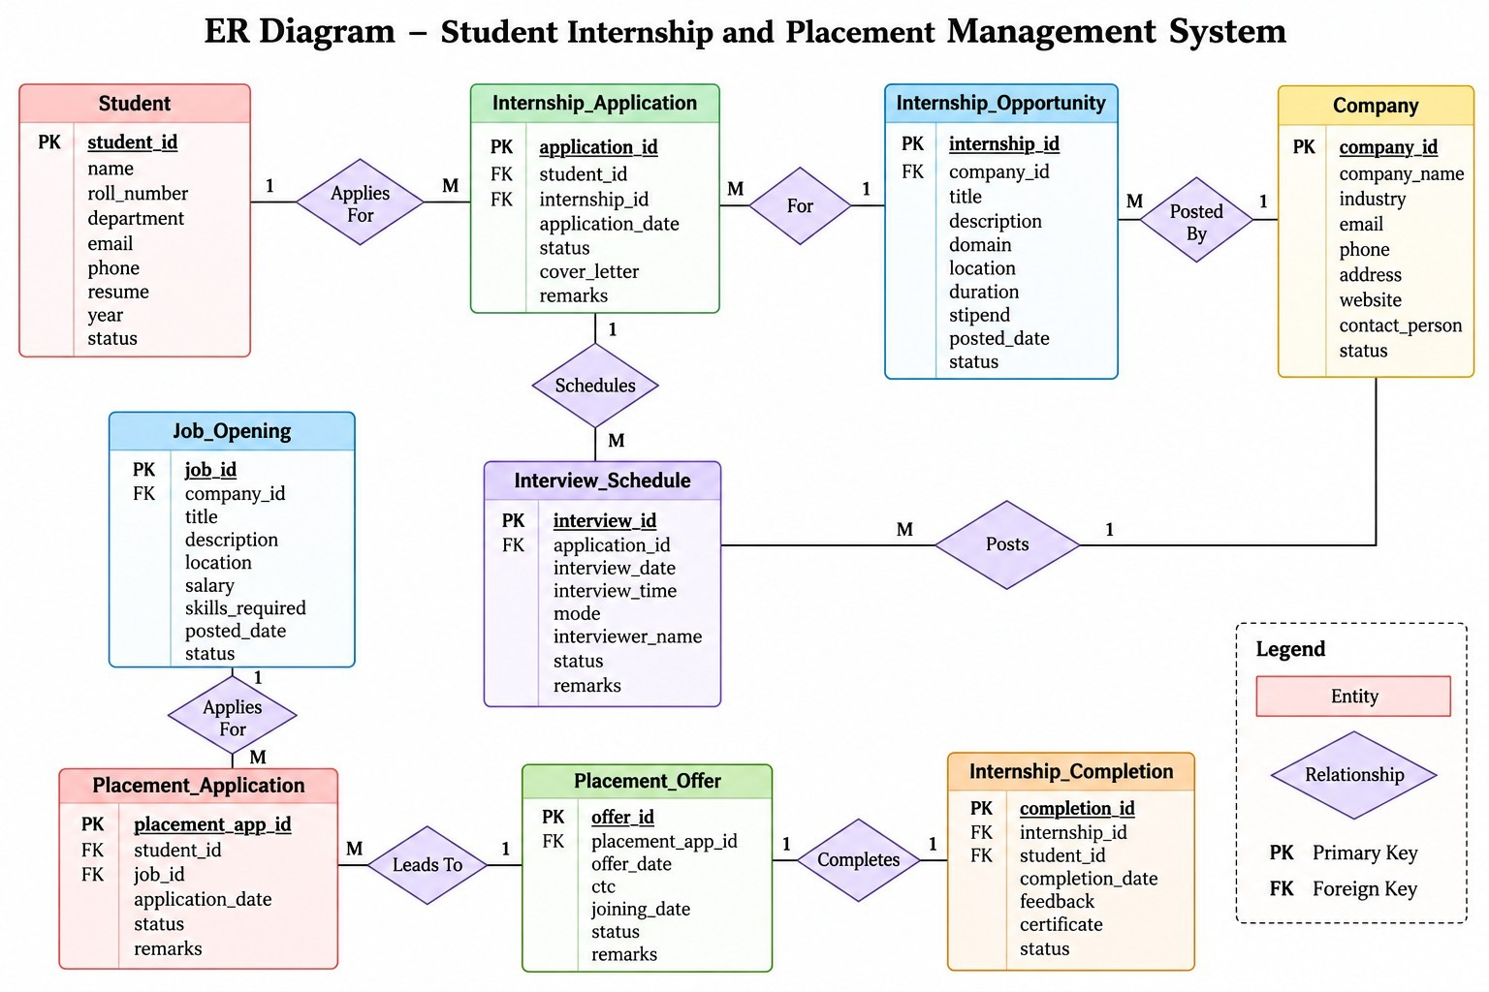

Figure 4.2: Entity–Relationship Diagram

Entity (Form) | Key Information | Related To | Relationship / Implementation
Student_Registration_Form | Student identity, academic and contact details | Applications, interviews, offers, completion | Lookup relationships where configured
Company_Registration_Form | Company identity and contact details | Internships, jobs, offers | Lookup relationships where configured
Internship_Opportunity_Form | Internship title, eligibility, dates  and company | Internship applications | Company lookup reported in  initial form
Job_Opening_Form | Job title, eligibility, deadline and company | Placement applications and offers | Lookup relationships where configured
Internship_Application_Form | Student, opportunity, date, resume, status | Student and internship opportunity | Lookup fields intended; verify live configuration
Placement_Application_Form | Student, job, date, resume, status | Student and job opening | Lookup fields intended; verify live configuration
Interview_Schedule_Form | Student, company, role, date/time, status, feedback | Application / candidate | Related application linkage may need manual configuration
Placement_Offer_Form | Student, company, position,  salary, dates, status | Student and placement  application | Related lookups intended; verify  live configuration
Internship_Completion_Form | Student, application, dates, certificate, status | Student and internship application | Related lookups intended; verify live configuration
Table 4.1: Entities and Relationships

4.3

4.3Form Design
The application contains nine main forms. Auto Number fields provide identifiers where configured, dropdowns standardise statuses, file-upload fields support resumes or completion certificates, and multi-line fields capture remarks or feedback. The table below summarises the main form purposes; exact field link names, mandatory flags, and lookup targets should be taken from the live Creator configuration before final submission.
Table 4.2: Form Field Specification Summary

Form Name | Important Fields / Types | Validation or Default Status
Student_Registration_Form | Student identity and academic details; fields depend on live form | Student status workflow reportedly sets Active
Company_Registration_Form | Company name and contact details | Required fields and unique constraints to verify
Internship_Opportunity_Form | Company, internship details, dates and eligibility | Company lookup reported; deadline/status fields to verify
Job_Opening_Form | Company, job title, dates and eligibility | Open/closed status and deadline fields to  verify
Internship_Application_Form | Auto Number, student, opportunity, date, resume, status, remarks | Status default Applied; duplicate/deadline validation reported
Placement_Application_Form | Auto Number, student, job, date, resume, status, remarks | Status default Applied; duplicate/deadline validation reported
Interview_Schedule_Form | Auto Number, student/company or application reference, date/time, mode, status, feedback | Status default Scheduled
Placement_Offer_Form | Auto Number, student, company, job application, position, salary, offer/joining dates, status | Status default Pending; salary validation reported
Internship_Completion_Form | Auto Number, student, application, start/end dates, certificate, feedback, status | Status default In Progress

The template asks for a field-by-field specification including field label, link name, field type, mandatory status, validation/default, and remarks. Since the live field link names and mandatory settings were not supplied in the conversation, they are not invented here. Before submission, add one detailed table per form using screenshots or exported field definitions from Zoho Creator.
  - Process and Workflow Design
The intended process is: register student and company; create internship/job opportunities; record applications; validate required information; schedule interviews; record placement offers; and record internship completion. Workflow triggers reported by Zia are primarily on record creation. Application and offer validation workflows were reported to include custom Deluge logic, but their source code and behaviour must be tested.

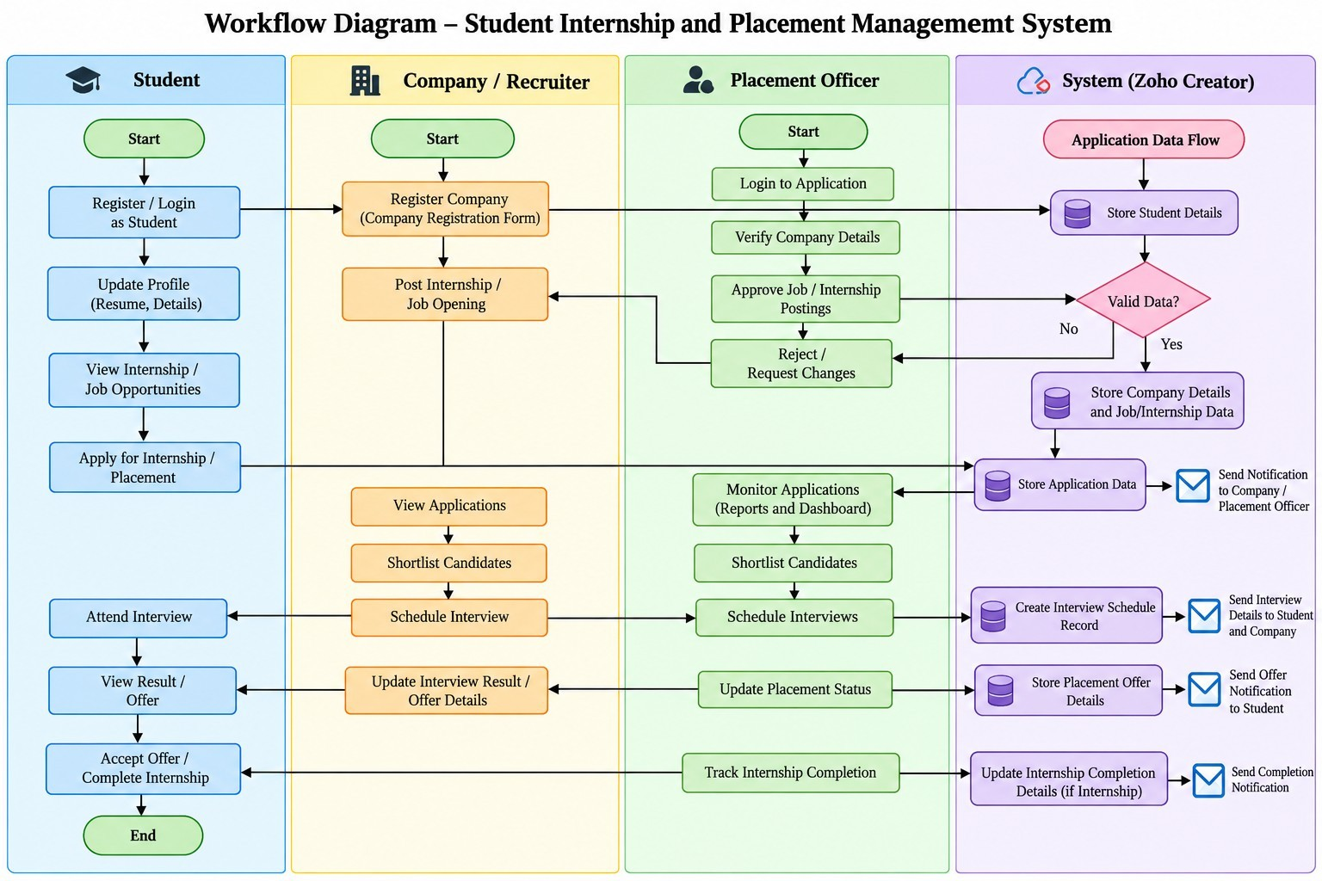

Figure 4.3: Workflow / Process Flow for Internship and Placement Management

4.5 User Interface and Navigation Design
The application menu is organised into Student Management, Company Management, Opportunity Management, Application Management, Interview Management, Placement Management, and Internship Completion. Reports are available from the menu, and the Student_Placement_Dashboard contains six summary cards and three pie charts.

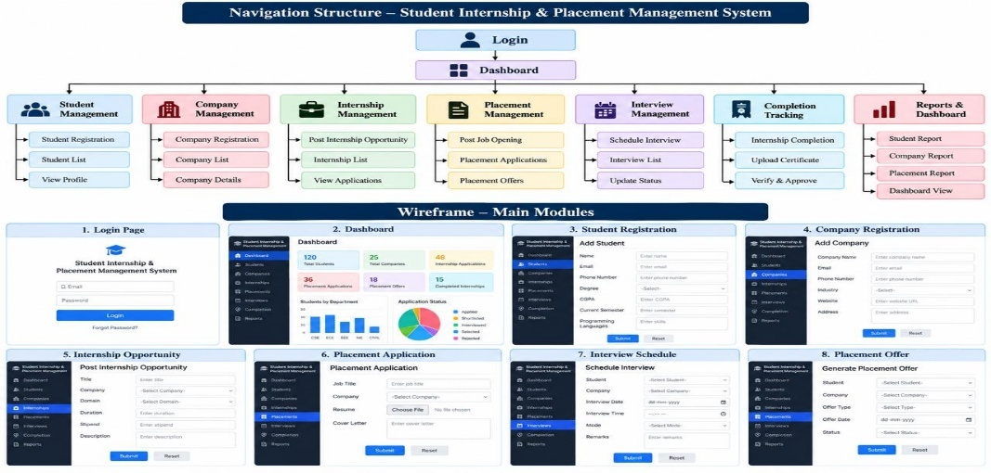
Figure 4.4: Navigation Structure and Dashboard Wireframe

4.6 Access Control Design
A permission matrix is included as a design proposal. It does not claim that these roles have been configured in Zoho Creator. The live permissions and record-level restrictions must be reviewed before the system is used with real student information.
Table 4.3: Role–Permission Matrix (Proposed; verify implementation)

Component | Administrator | Placement Officer | Recruiter | Student
Student records | Add/Edit/View/Delete | Add/Edit/View | Assigned records only if configured | Own record only if portal configured
Company and opportunity records | Full access | Add/Edit/View | View assigned opportunities if  configured | View open opportunities if portal configured
Applications | Full access | Manage all | Assigned applications if configured | Own applications if portal configured
Interview records | Full access | Manage all | Assigned interviews if  configured | Own interviews if portal  configured
Placement offers / completion | Full access | Manage all | View assigned records if configured | Own records if portal configured
Dashboard and reports | Full access | View relevant reports | Restricted reports if configured | Own status only if configured

CHAPTER 5 IMPLEMENTATION
  - Application Setup
The application was built in Zoho Creator with assistance from the Zia Build Agent. The builder was instructed to create the forms first, then reports, dashboard components, and workflows in separate stages to keep configuration manageable. The reported menu sections are Student Management, Company Management, Opportunity Management, Application Management, Interview Management, Placement Management, and Internship Completion.
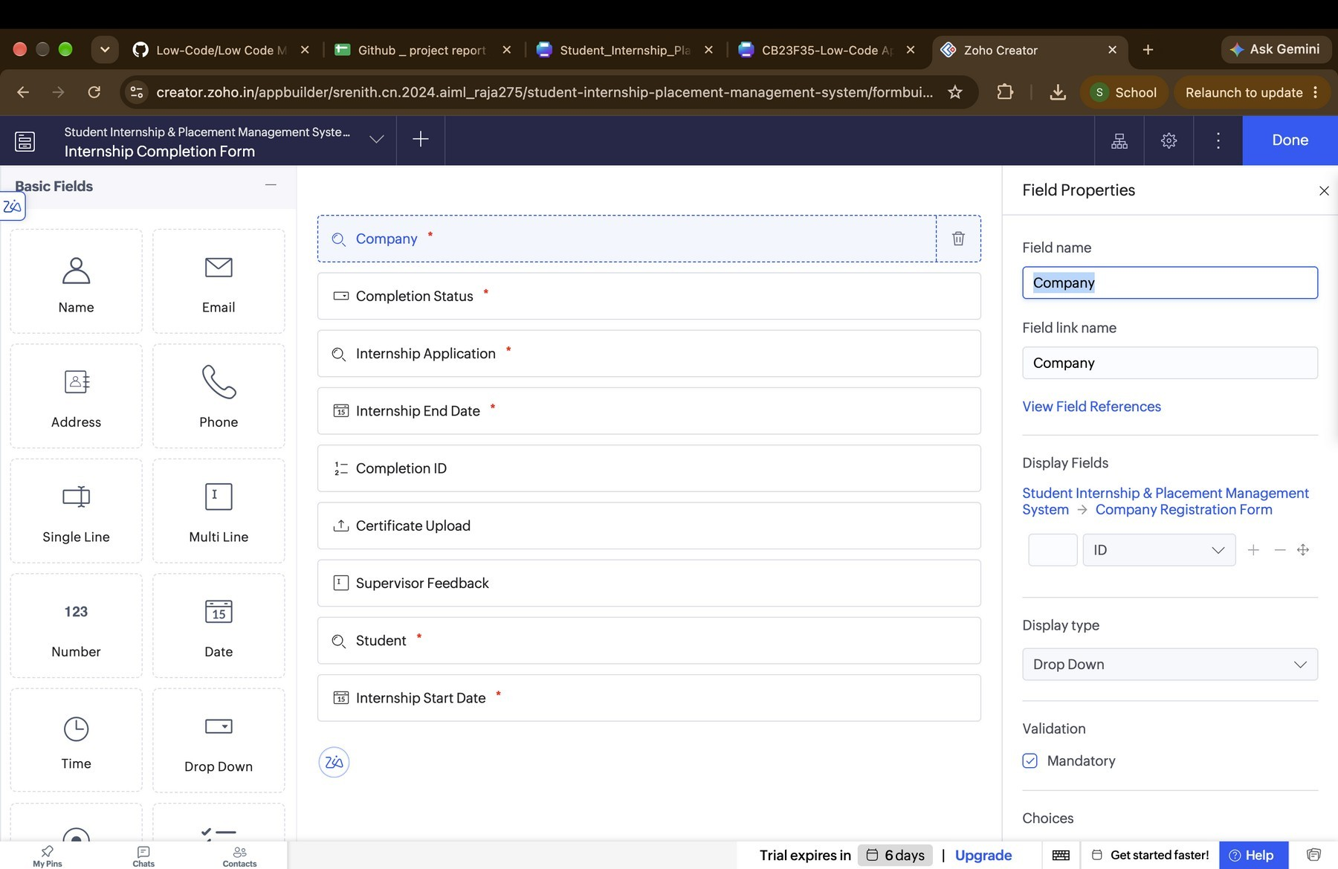
Figure 5.1: Application Home and Navigation Sections

  - Forms and Data Capture
Nine forms are reported as created:Student_Registration_Form, Company_Registration_Form,Internship_Opportunity_Form,Job_Opening_Form, Internship_Application_Form,Placement_Application_Form,Interview_Schedule_Form,Placement_Offer_Form, and Internship_Completion_Form. They capture the main records required for the recruitment lifecycle. The forms include fields such as identifiers, names, dates, dropdown statuses, resumes, certificates, remarks, and interview feedback, as applicable to each form.

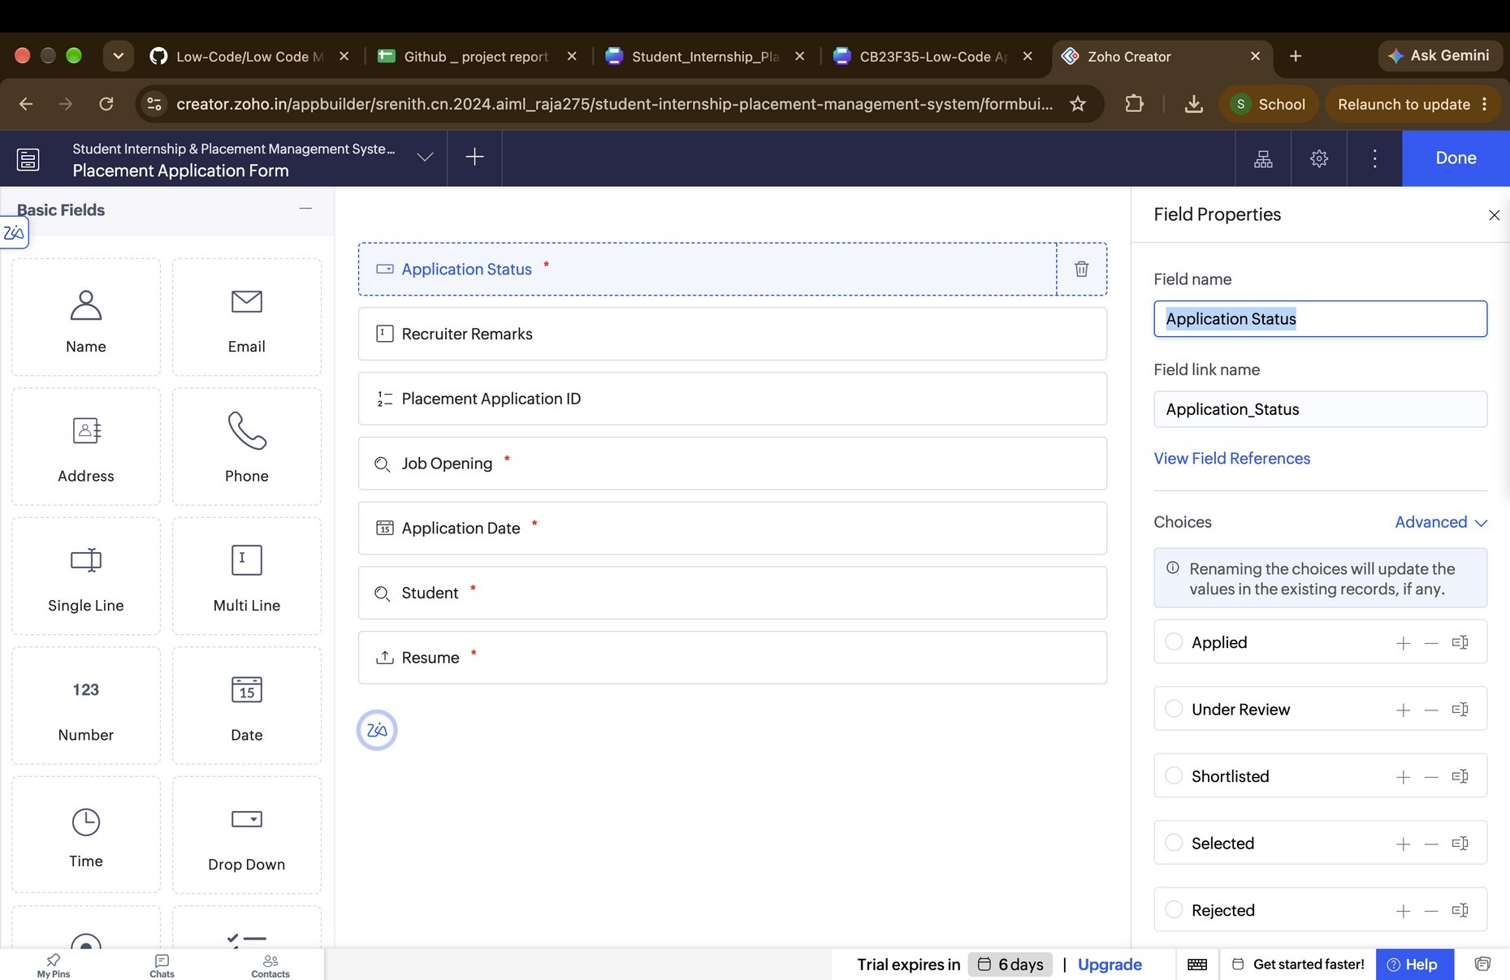

Figure 5.2: Form Builder Screenshot

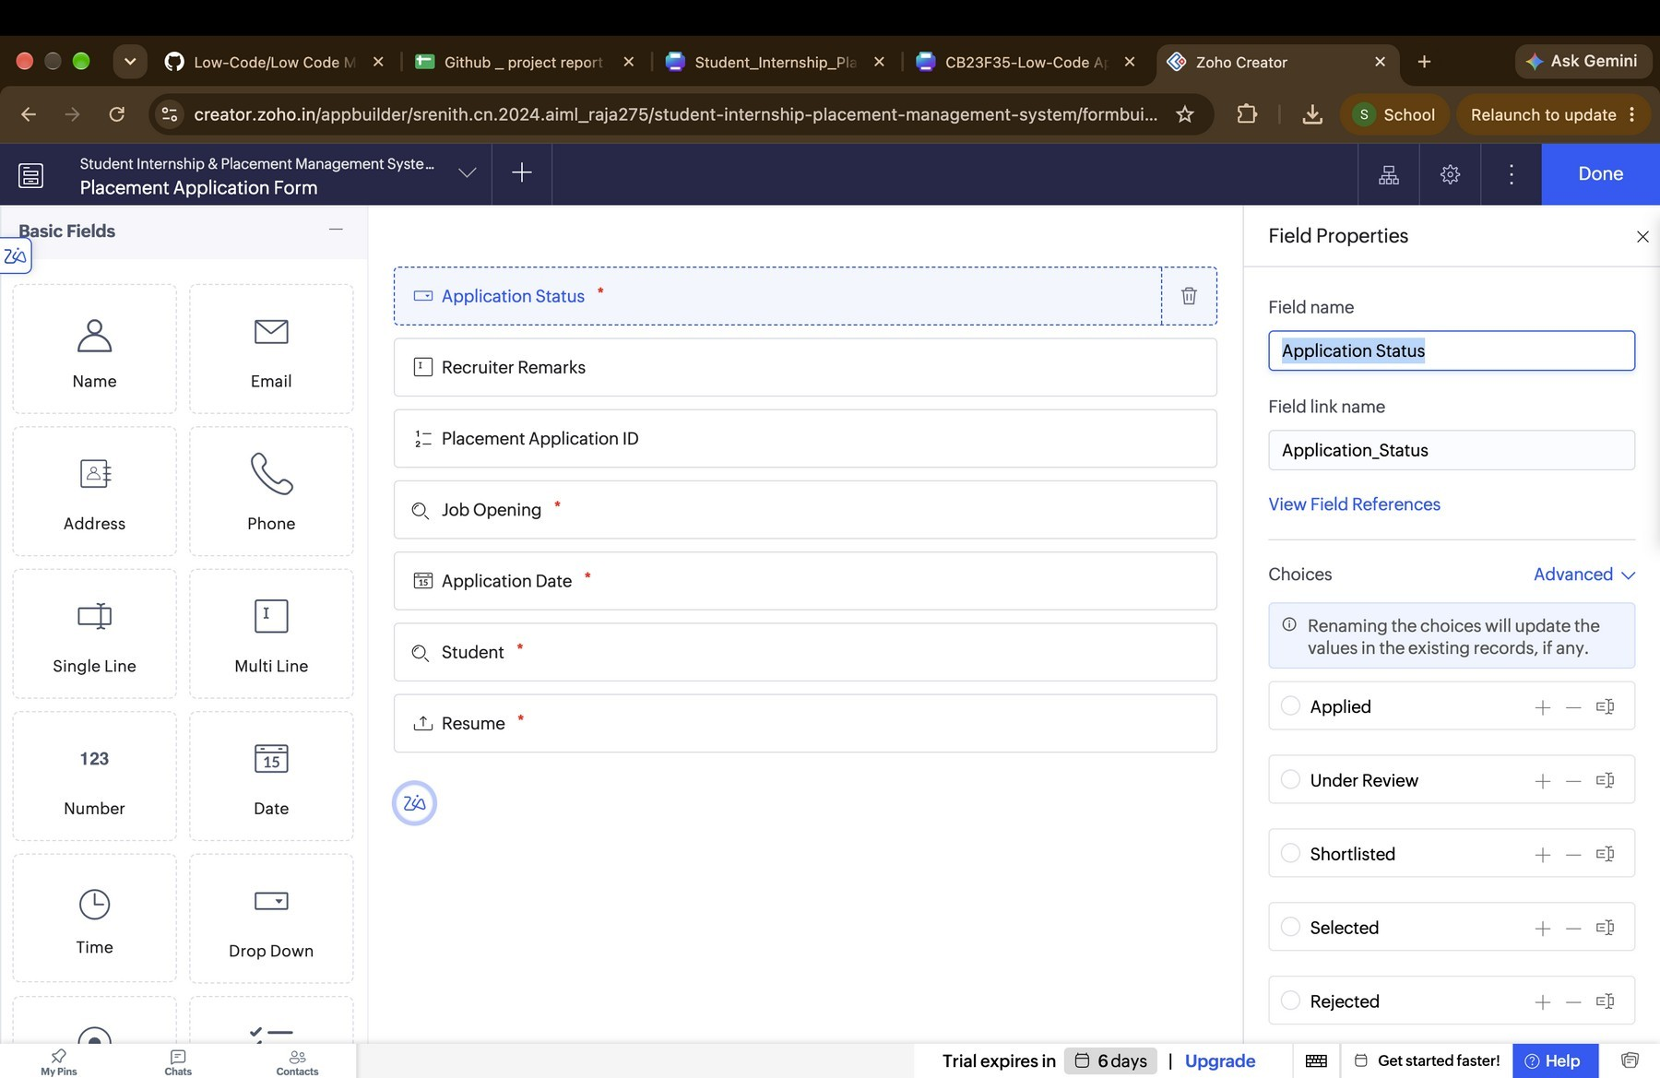

Figure 5.3: Live Form Screenshot

  - Reports
Nine reports were reported as created and added to the menu. The exact report names and report types should be checked in the live app; the names below reflect the confirmed report set from the build conversation.
Table 5.1: Reports Implemented

Report Name | Source Form | Purpose | Status
Student_List | Student_Registration_Form | View registered students | Reported created; verify live
Company_List | Company_Registration_For m | View registered companies | Reported created; verify live
Internship_List | Internship_Opportunity_For m | View internship opportunities | Reported created; verify live
Job_List | Job_Opening_Form | View job openings | Reported created; verify live
Internship_Applications | Internship_Application_For m | Review internship applications and statuses | Reported created; verify live
Placement_Applications | Placement_Application_For m | Review job applications and statuses | Reported created; verify live
Interview_List | Interview_Schedule_Form | View interview schedules | Reported created; verify live
Placement_Offers | Placement_Offer_Form | Review offers, packages and statuses | Reported created; verify live
Internship_Completions | Internship_Completion_For m | View completion records | Reported created; verify live

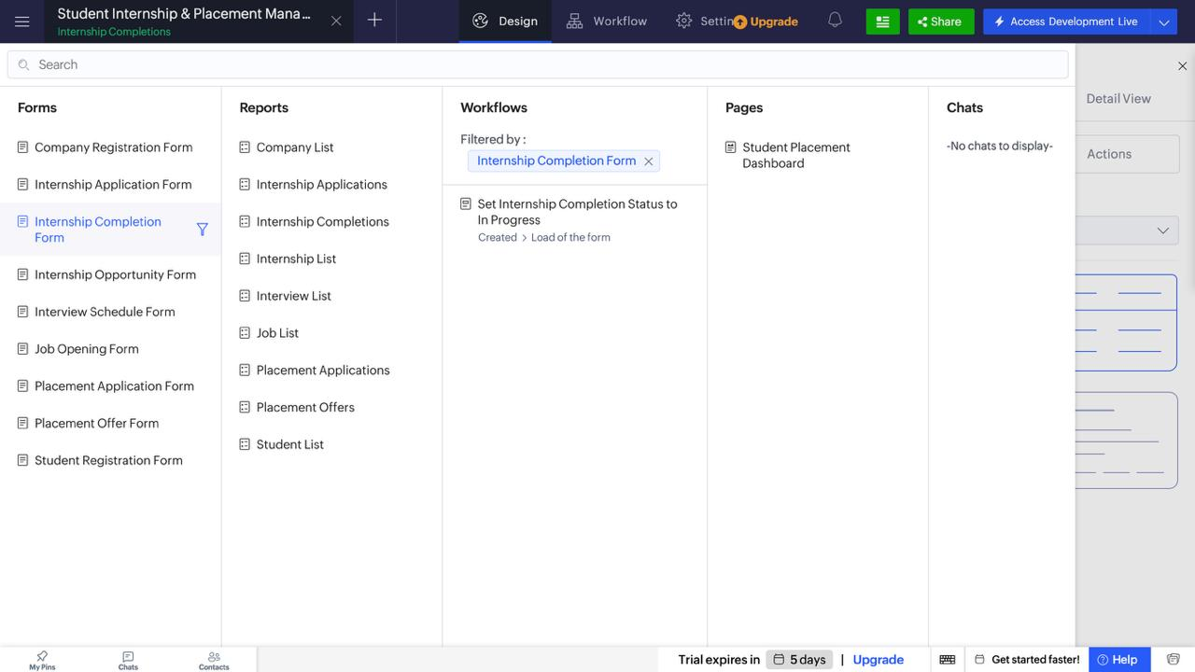

Figure 5.4: Report Screenshot

5.4 Pages and Dashboards
The Student_Placement_Dashboard was reported as created with six summary cards and three pie charts. The six cards are intended to show total students, total companies, internship applications, placement applications, placement offers, and completed internships. The three charts are intended to show students by department, internship applications by status, and placement applications by status. The values must be verified against actual saved records before claiming that they are correct.

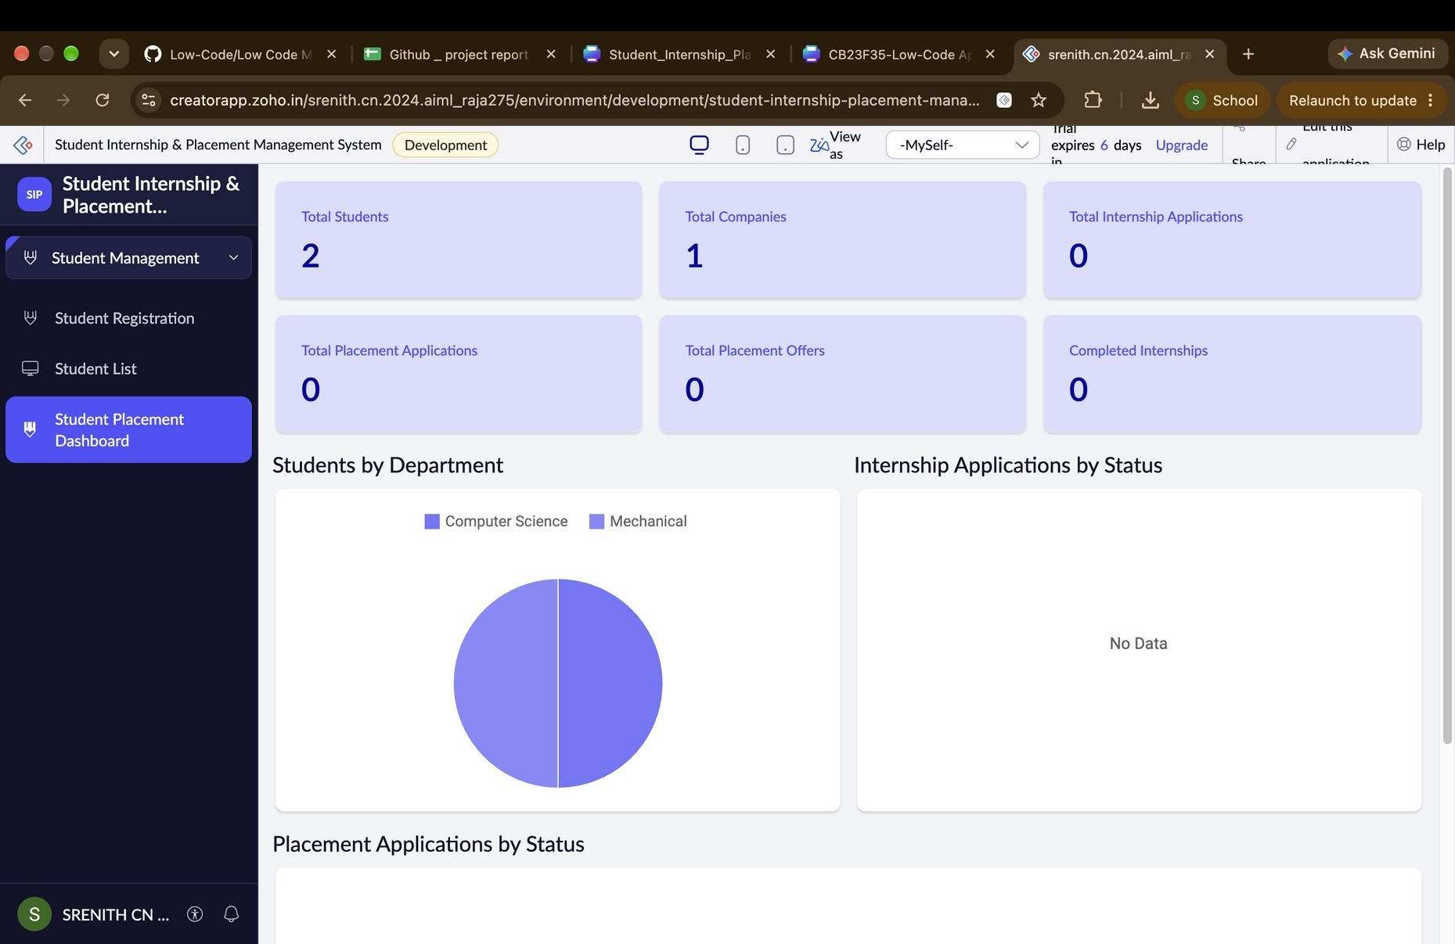5: Figure 5.5 Student Placement Dashboard

5.5 Deluge Scripting
The Zia Build Agent reported adding Deluge logic to three validation workflows: Internship Application Validation, Placement Application Validation, and Placement Offer Validation. The actual source code was not provided in the conversation, so this report does not reproduce guessed scripts. Copy the complete scripts from the Zoho Creator workflow editor into Appendix C and verify their syntax and behaviour.
Table 5.2: Deluge Scripts Implemented

Script ID | Location / Trigger | Purpose | Deluge Concepts
DS-01 | Internship Application Validation / form submission | Check required relationship fields, duplicates, and deadline where implemented | Conditions, record lookup, alert/cancel submit (verify exact code)
DS-02 | Placement Application Validation / form submission | Check required relationship fields, duplicates, and deadline where implemented | Conditions, record lookup, alert/cancel submit (verify exact code)
DS-03 | Placement Offer Validation / form submission | Check required offer fields and salary greater than zero | Conditions, validation message and submission cancellation (verify exact code)

Code 5.1 [validation script – placement offer]

if(input.Student.isNull()){
alert "Student selection is required";
cancel submit;
}
if(input.Company.isNull()){
alert "Company selection is required";
cancel submit;
}
if(input.Offered_Position.isBlank()){
alert "Offered Position is required";
cancel submit;
}
if(input.Joining_Date.isNull()){
alert "Joining Date is required";
cancel submit;
}
if(input.Annual_Salary_Package.isNull() || input.Annual_Salary_Package <= 0){
alert "Enter a valid positive salary package";
cancel submit;
}

Code 5.2 Internship application reminder

studentRecord = Student_Registration_Form[ID == input.Student];
internshipRecord = Internship_Opportunity_Form[ID == input.Internship_Opportunity];
studentName = studentRecord.Full_Name.first_name + " " + studentRecord.Full_Name.last_name;
studentEmail = studentRecord.Email_Address;
internshipTitle = internshipRecord.Internship_Title;
sendmail[
from : zoho.adminuserid
to : studentEmail
subject : "Internship Application Confirmation - " + internshipTitle
message : "Dear " + studentName + ",<br><br>Your application for <b>" + internshipTitle + "</b> was submitted successfully.<br><br>Application Date: " + input.Application_Date + "<br>Status: " + input.Application_Status + "<br><br>Best regards,<br>Placement Team"
content type : HTML]

Script 1 – Placement Offer Validation: The script validates the placement offer form by checking whether the student, company, offered position, joining date, and salary are provided. It also ensures that the annual salary package is greater than zero. If any field is missing or the salary is invalid, an alert is displayed and submission is cancelled. The result is that only valid placement offers can be submitted.

Script 2 – Internship Email Notification: The script retrieves the student’s name and email address, along with the internship title, application date, and status. It then creates an email containing the application confirmation details and sends it to the student. The result is that the student receives an email confirming successful application submission, provided the workflow and email configuration work correctly.

5.6 Workflows and Automation
The build conversation reports that the following default-status workflows were created and enabled. Three additional validation workflows were reported as enabled, and custom Deluge logic was later reported as added to those validation workflows. The workflow list in Zoho Creator should be checked for the exact total and trigger/action details.

Table 5.3: Workflows Implemented

Workflow Name | Type | Trigger / Event | Action | Evidence Status
Set Student Status to Active | Form workflow | Student record creation | Set status to Active | Reported enabled; test with record
Set Internship Application Status to Applied | Form workflow | Internship application creation | Set status to Applied | Reported enabled; test with record
Set Placement Application Status to  Applied | Form workflow | Placement application creation | Set status to Applied | Reported enabled; test with record
Set Interview Status to Scheduled | Form workflow | Interview creation | Set status to Scheduled; do not overwrite on edit as reported | Reported enabled; test with record
Set Placement Offer  Status to Pending | Form workflow | Placement offer creation | Set status to Pending | Reported enabled; test  with record
Set Internship Completion Status to In Progress | Form workflow | Completion record creation | Set status to In Progress; do not overwrite on edit as reported | Reported enabled; test with record
Internship Application  Validation | Form workflow | Form submission | Validation logic  reportedly added | Inspect code and test  negative cases
Placement Application Validation | Form workflow | Form submission | Validation logic reportedly added | Inspect code and test negative cases
Placement Offer Validation | Form workflow | Form submission | Validation logic reportedly added | Inspect code and test negative cases

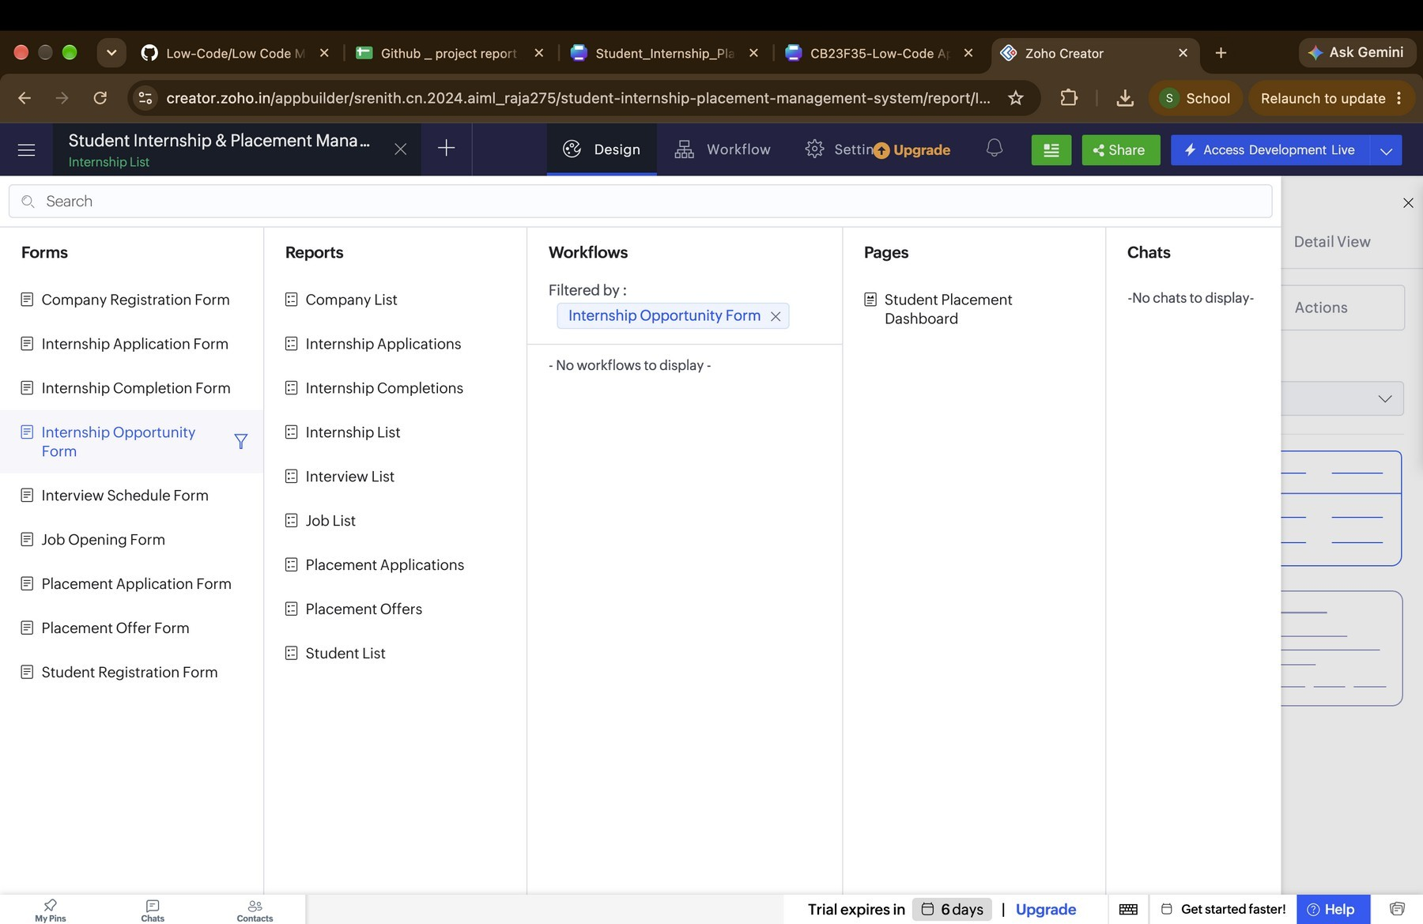
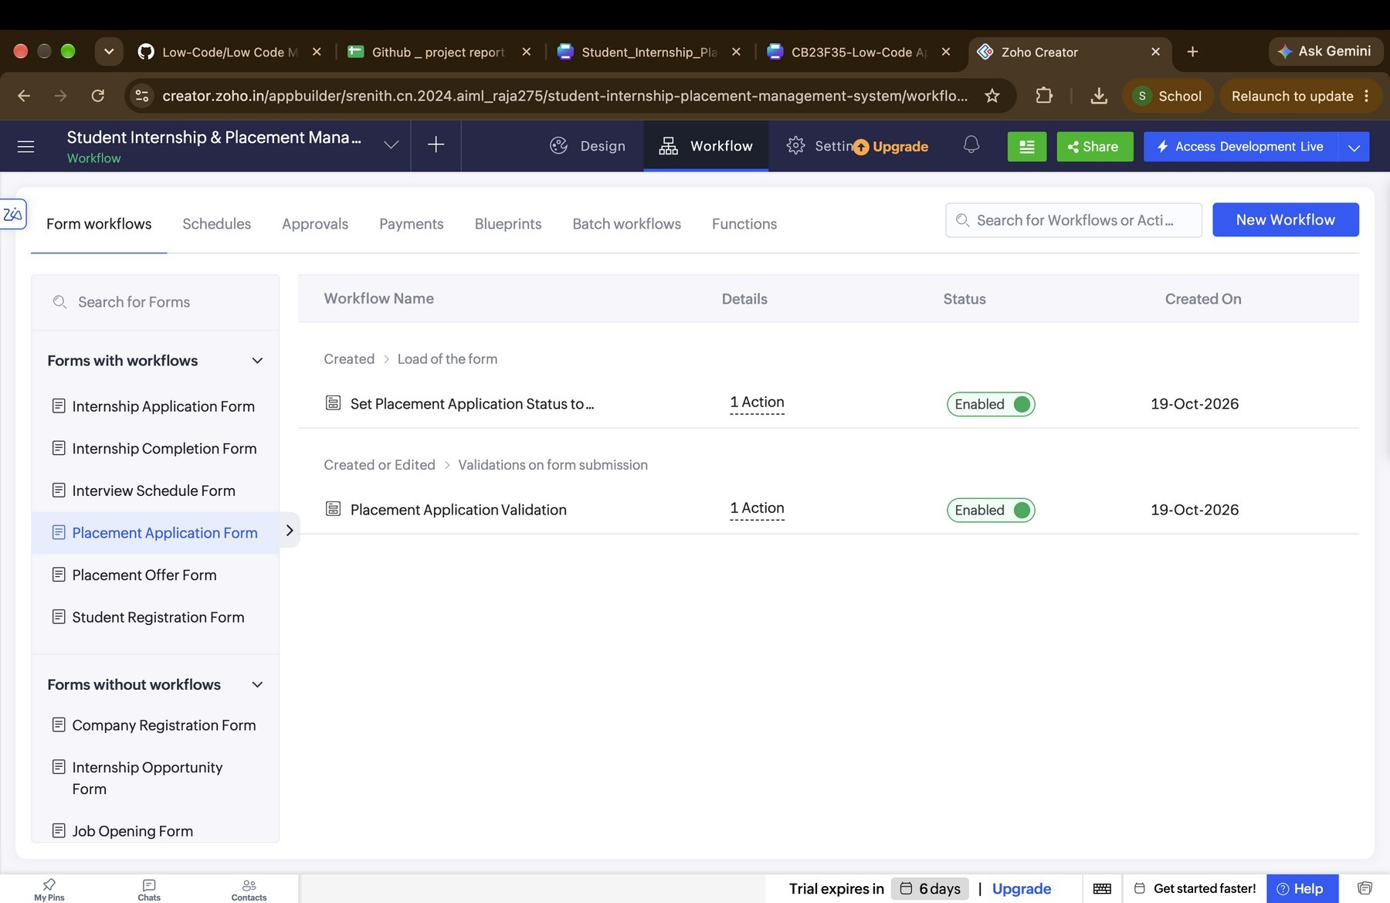

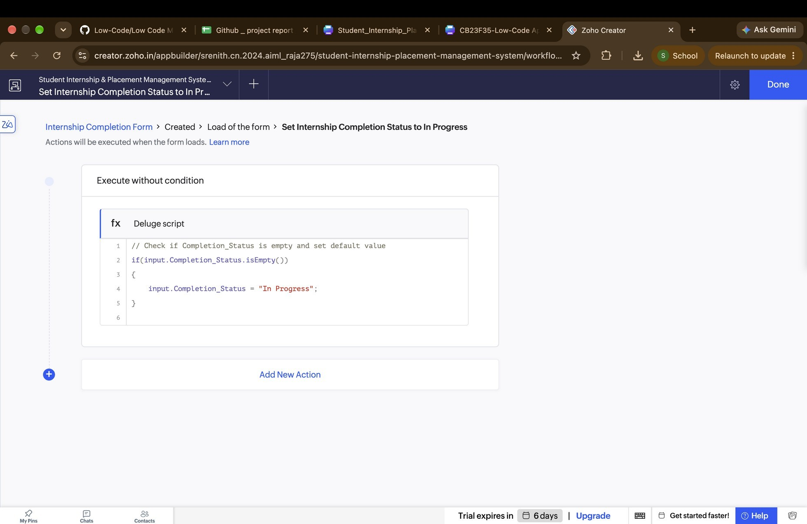

Figure 5.6: Workflow Configuration

5.7 Integrations
No connection to Zoho CRM, Zoho Mail, a third-party job board, or an external REST API was confirmed in the project build conversation. Therefore, the integration section is retained as required by the template, but no integration is claimed as implemented. An integration could be added in future using a configured connection and secure authentication, with testing evidence.
Table 5.4: Integrations Implemented

- Integration | - Service / Endpoint | - Method | - Authentication | - Status
- None confirmed | - Not applicable | - Not applicable | - Not applicable | - Not implemented / not verified

Code 5.3:[Integration script -Internship Application Confirmation]
studentRecord = Student_Registration_Form[ID == input.Student];
internshipRecord = Internship_Opportunity_Form[ID == input.Internship_Opportunity];
studentEmail = studentRecord.Email_Address;
internshipTitle = internshipRecord.Internship_Title;
sendmail[
from : zoho.adminuserid
to : studentEmail
subject : "Internship Application Confirmation"
message : "Your application for " + internshipTitle + " has been submitted successfully."];

Not evidenced

5.8 User Management and Role-Based Access
The intended stakeholders include an administrator, placement officer, recruiter, and student. However, the build conversation does not confirm that separate user roles, permission profiles, student portal access, or record-level restrictions were configured. This section is retained because the template requires it. Before claiming RBAC, configure the roles and test access using separate accounts.

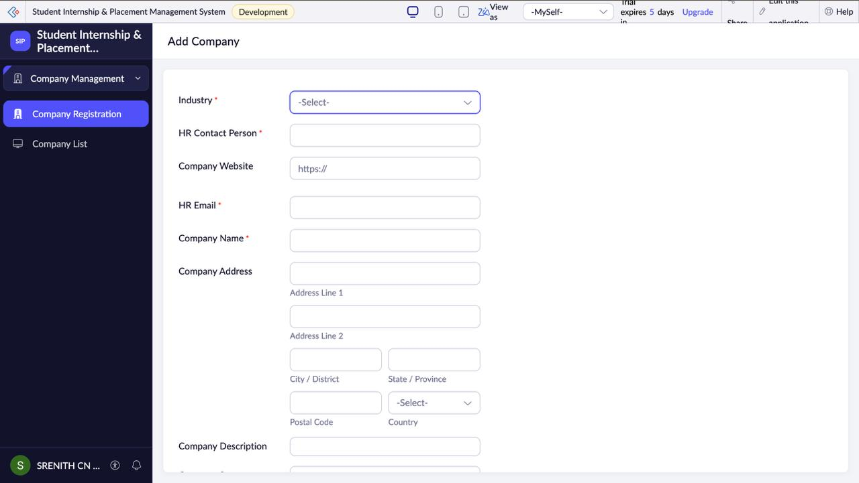
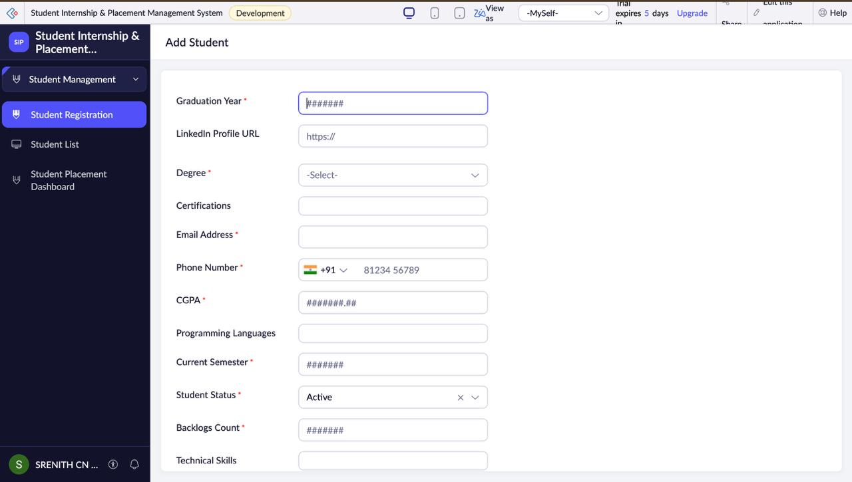

Figure 5.8:Student Role Form and Company Report

  - AI and Analytics Features
Zia Build Agent was used to assist with creating forms, reports, dashboard components, and workflows. The dashboard contains six summary cards and three pie charts as reported by Zia. AI assistance was used for application configuration; the business rules should be reviewed and tested by the developer. No predictive model, OCR, sentiment analysis, or external Zoho Analytics integration is confirmed.

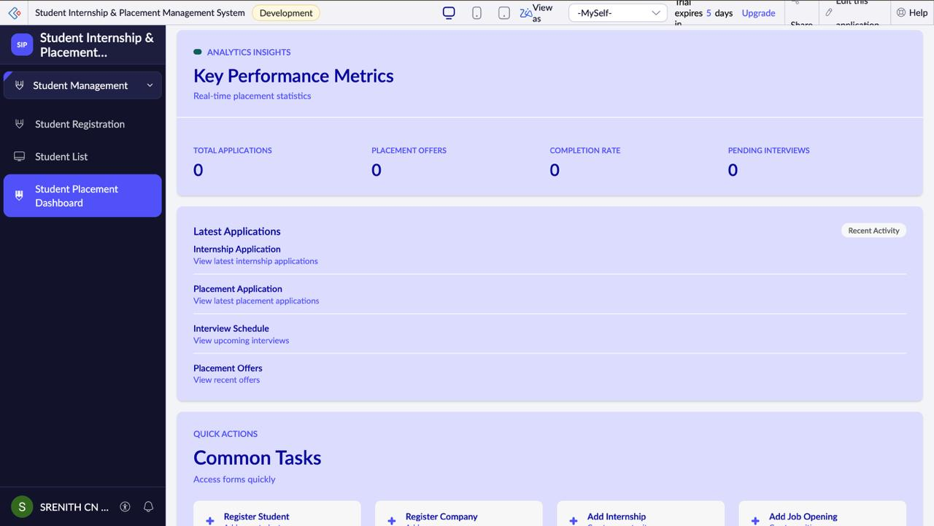

Figure 5.9: Zia / Analytics Feature in Use

5.10 Pro-Code Extension
A pro-code extension using Zoho Catalyst, custom JavaScript widgets, or a separate backend service was not used in the current project. The application requirements were addressed through Creator forms, reports, dashboard components, and workflows. A pro-code extension may be considered if future requirements demand complex matching algorithms, advanced analytics, external job-board synchronisation, or custom user experiences that exceed the platform's low-code capabilities.

5.11 Mobile and Portal Access
Mobile access and a student-facing portal were not confirmed in the current build. This section is retained to follow the template. If the application is accessed through the Zoho Creator mobile application or a configured portal, insert screenshots and describe the exact access settings. Otherwise, record the feature as not implemented.

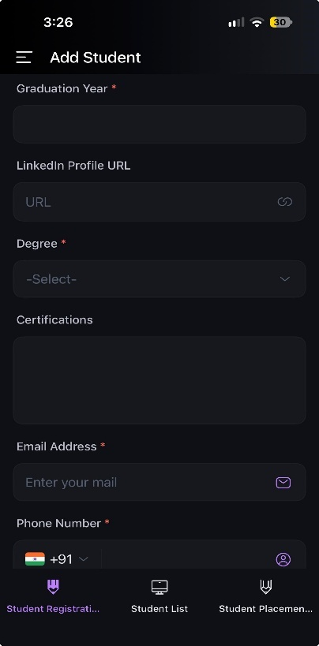

Figure 5.10: Mobile / Portal Access

CHAPTER 6 TESTING AND DEBUGGING
  - Testing Strategy
Testing should cover each form, each report, workflow triggers, validation failures, and dashboard calculations. Unit testing checks whether individual forms accept valid records and reject invalid ones. Integration testing checks whether saved records appear in the correct reports and whether dashboard counts change. Negative testing checks duplicate applications and invalid salary values. Role-based testing should be performed only after separate roles and permissions are configured.
At the time this report was prepared, Zia had reported that forms, reports, dashboard, and workflows were created. The conversation did not contain test execution evidence from real sample records. Therefore, the cases below are test plans; update Actual Result and Status after executing them.
6.2 Test Cases
Table 6.1: Test Cases

TC ID | FR Ref. | Test Description | Input / Steps | Expected Result | Actual Result | Status
TC-01 | FR-01 | Create student with required fields | Valid student details | Student record saved | Pending | Pending
TC-02 | FR-01 | Omit a mandatory  student field | Leave required field blank | Validation message; record  not saved | Pending | Pending
TC-03 | FR-02 | Create company record | Valid company details | Company record saved | Pending | Pending
TC-04 | FR-03 | Create internship opportunity | Valid opportunity and company | Opportunity saved and listed | Pending | Pending
TC-05 | FR-03 | Create job opening | Valid job and company | Job saved and listed | Pending | Pending
TC-06 | FR-04 | Submit valid internship application | Existing student and internship | Application saved and status Applied | Pending | Pending
TC-07 | FR-12 | Submit duplicate internship application | Same student and opportunity twice | Second submission rejected if duplicate rule is implemented | Pending | Pending
TC-08 | FR-12 | Apply after internship deadline | Deadline in past, if field exists | Submission rejected if deadline rule is implemented | Pending | Pending
TC-09 | FR-05 | Submit valid placement application | Existing student and job | Application saved and status Applied | Pending | Pending
TC-10 | FR-12 | Submit duplicate placement application | Same student and job twice | Second submission rejected if duplicate rule is implemented | Pending | Pending
TC-11 | FR-06 | Create interview record | Valid interview date/time | Interview saved with Scheduled status | Pending | Pending
TC-12 | FR-07 | Create placement offer with valid salary | Salary greater than zero | Offer saved with Pending status | Pending | Pending

TC-13 | FR-12 | Create placement offer with zero salary | Salary = 0 | Submission rejected if validation is implemented | Pending | Pending
TC-14 | FR-08 | Create internship completion record | Valid student/applicati on and dates | Completion saved with In Progress status | Pending | Pending
TC-15 | FR-09 | Open all reports | Saved sample records exist | Each report displays its matching records | Pending | Pending
TC-16 | FR-10 | Check dashboard summary cards | Known sample records exist | Counts match records in  forms/reports | Pending | Pending
TC-17 | FR-10 | Check dashboard pie charts | Records have different statuses/departm ents | Slices reflect actual record counts | Pending | Pending
TC-18 | NFR-04 | Test unauthorised  access | Use a non-admin test account if  configured | Restricted data is inaccessible | Pending | Pending

6.3 Debugging Deluge Scripts
The validation workflows were reported as updated with Deluge logic. Debugging should include reviewing the exact code in the workflow editor, checking field link names and lookup criteria, using the platform's available error messages or logs, and submitting both valid and invalid records. One reported builder issue during development was a Zoho Creator builder error involving missing lookup metadata; the Zia agent attributed it to a possible builder metadata issue. It should be mentioned as a development observation only if it was actually encountered in this app, and any final fix should be documented from the live environment.

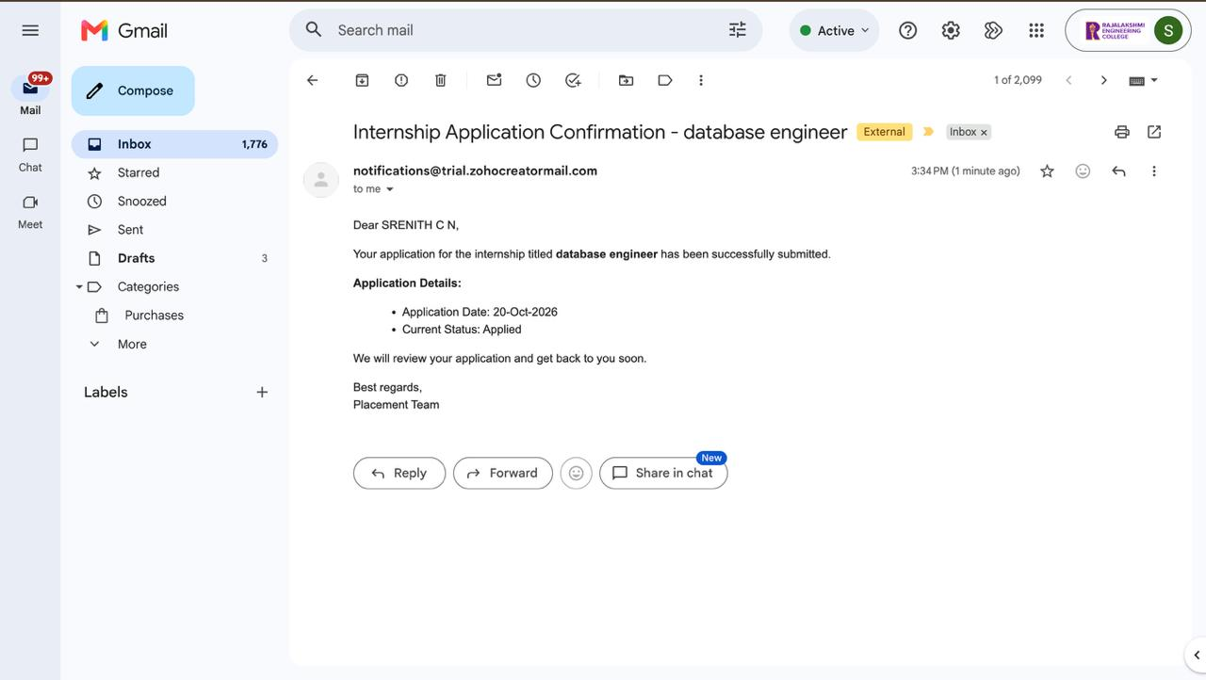

Figure 6.1: Deluge Debug Output/Log

  - Defect Log
Table 6.2: Defect Log

Bug ID | Description | Root Cause | Fix Applied | Status
BUG-01 | Builder error reported in an earlier form-building stage: missing lookup reference metadata | Possible builder metadata/platform issue according to the builder assistant; root cause not confirmed | The forms were later reported as successfully created; exact repair steps not documented | Closed by continued build; verify no recurrence
BUG-02 | Validation workflows require actual negative-case testing | No test evidence supplied yet | Run duplicate-application and zero-salary tests | Open / pending testing

6.5 User Acceptance Testing
The template requests feedback from at least two end users. No actual user feedback was supplied during preparation of this report. Complete the table after two users operate the application and provide genuine feedback.
Table 6.3: User Acceptance Feedback
User | Role Tested | Feedback | Action Taken
[User 1 name] | [Role] | [Record actual feedback after test] | [Action taken]
[User 2 name] | [Role] | [Record actual feedback after test] | [Action taken]

CHAPTER 7
DEPLOYMENT, SECURITY AND GOVERNANCE

  - Environments and Deployment Strategy
The application was configured in Zoho Creator. The conversation does not confirm that separate development, staging, and production environments were used or that the app was formally published to production. Before submission, confirm whether the app has a live URL and record the deployment date only if publication has occurred.
Table 7.1: Deployment Checklist

S.No. | Checklist Item | Status
1 | Forms, reports and workflows reviewed in the build environment | Reported created; manual verification required
2 | Sample/test data removed or clearly isolated | Pending
3 | Roles and permissions configured and tested | Not recorded
4 | Connections authorised in production | Not applicable / no integrations confirmed
5 | Workflows saved and enabled | Reported enabled; test behaviour
6 | Application published and URL verified | Not recorded
7 | Version / release notes recorded | Pending

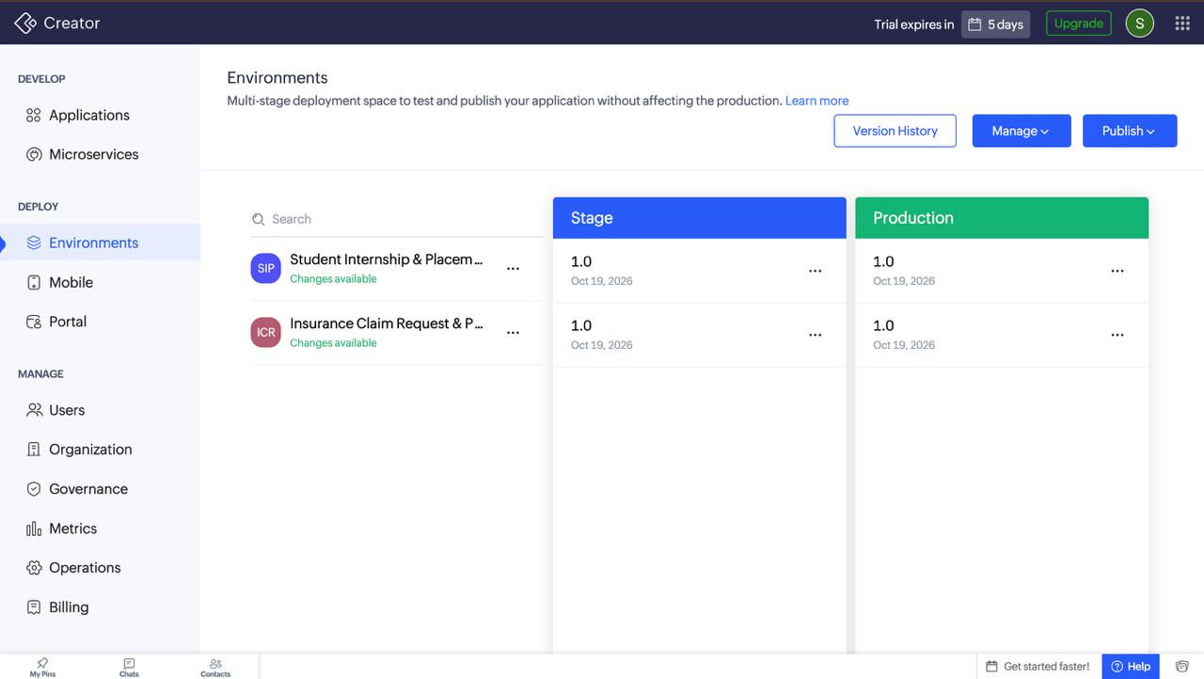

Figure 7.1: Environments / Publish to Production

  - Performance Optimisation
No measured performance benchmark was supplied. For a small student project, basic optimisation can include keeping reports focused on relevant fields, using appropriate filters, avoiding unnecessary repeated data lookups in custom Deluge code, and checking that dashboard cards use efficient data sources. Any claim of faster response time must be supported by before-and-after measurements.
Table 7.2: Performance Optimisation Results

Optimisation | Component | Before | After | Improvement

Applied
Use only relevant report columns | Reports | Not measured | Not measured | Not quantified
Use filtered views for relevant records | Reports | Not measured | Not measured | Not quantified
Review lookup/query logic in Deluge | Validation workflows | Not measured | Not measured | Not quantified

  - Security Features
The application may contain personal and academic student data, so access should be limited to authorised users. Security must be verified through Creator permission settings and separate-account tests. Do not include demo passwords in the report. The current conversation did not confirm encryption settings, record-level criteria, two-factor authentication, or a student portal.
Table 7.3: Security Controls Implemented

Security Control | Where Applied | Threat Mitigated / Status
Required fields and validation | Forms / validation workflows | Reduces incomplete or invalid records; test actual behaviour
Role-based permissions | Creator permissions | Not recorded; configure and test before real use
Record-level restrictions | Reports / data access | Not recorded; required for private student records
Secure integration connections | Integrations | No external integration confirmed
Credentials management | Application administration | Never include passwords in reports; use approved account controls

  - Governance and Administration
Governance practices should include consistent form and workflow names, documenting changes, reviewing permissions, exporting or backing up data according to college requirements, and checking workflow logs after changes. The application owner should confirm which audit trail and backup capabilities are available under the current Creator edition.

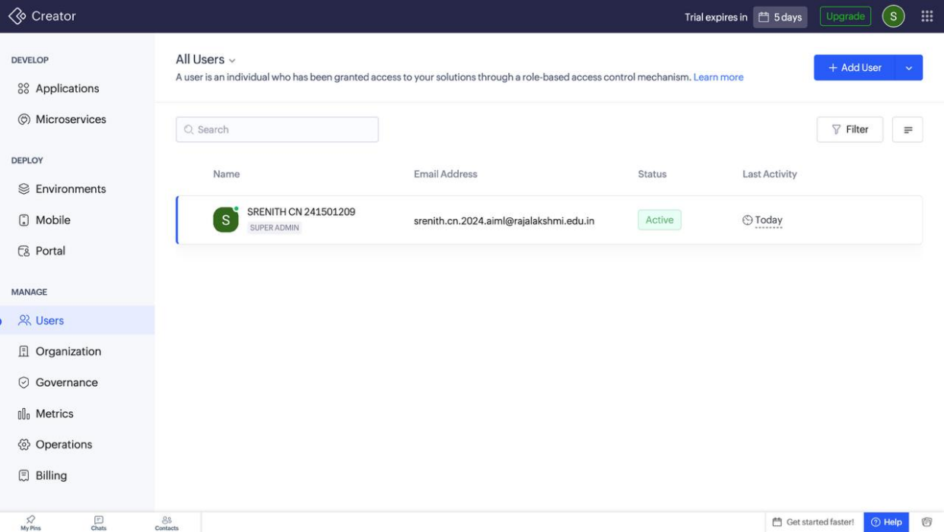

` Figure 7.2: Audit Trail / Administration Settings

CHAPTER 8 RESULTS AND DISCUSSION
  - Application Output
The reported application output consists of nine forms, nine reports, a dashboard with six summary cards and three pie charts, and workflows for default statuses and validation. The end-to-end scenario below describes the intended demonstration path. Capture real screenshots and update the results after performing each step.
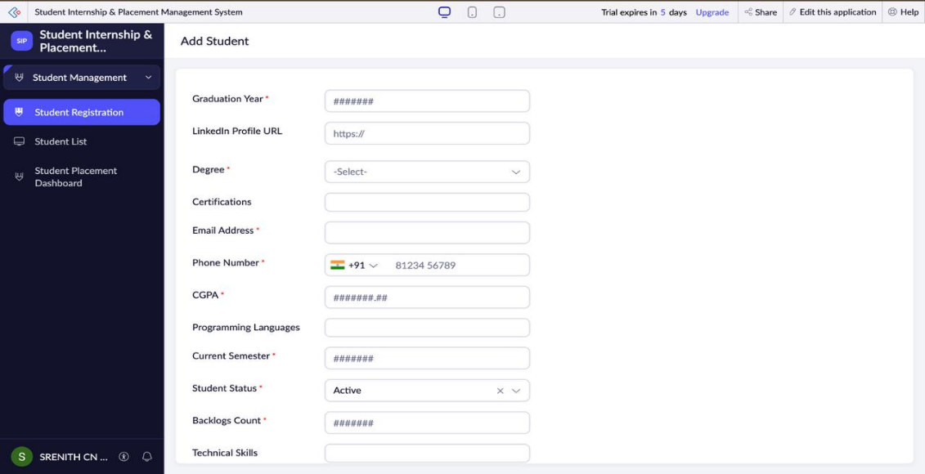

Figure 8.1: Scenario Step 1 – Student, company, internship and job records

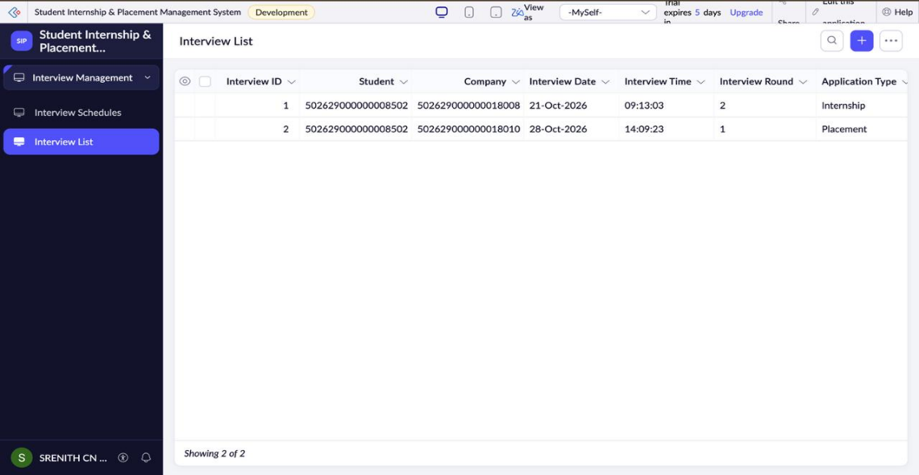

Figure 8.2: Scenario Step 2 – Application and interview records

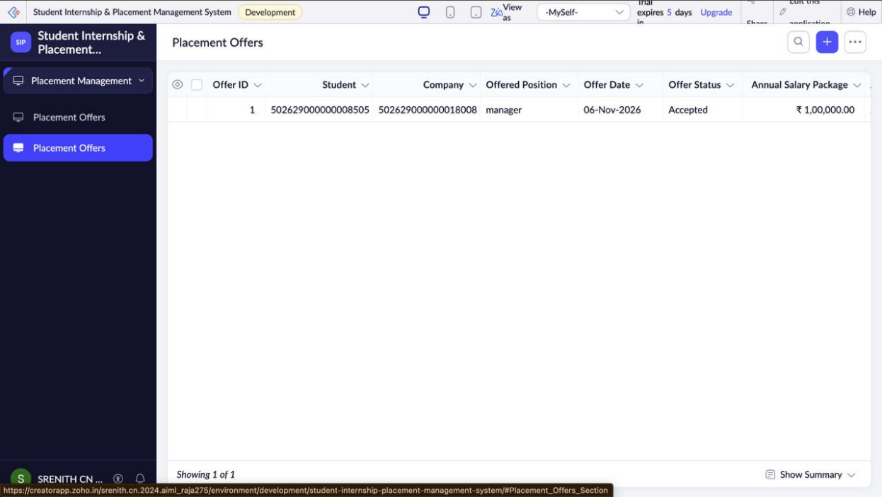

Figure 8.3: Scenario Step 3 – Offer/completion records and dashboard update

  - Achievement of Objectives
Table 8.1: Mapping of Objectives to Outcomes

Objective (Section 1.3) | Implemented Through | Outcome / Evidence
Create structured forms | Chapter 5.2 | Nine forms reported created; confirm

 |  | field definitions
Track applications | Chapter 5.2 and 5.3 | Internship and placement application forms/reports reported created
Maintain interviews, offers and completion | Chapter 5.2 and 5.3 | Forms and reports reported created
Provide reports | Chapter 5.3 | Nine reports reported created; live report content must be checked
Provide dashboard | Chapter 5.4 | Six cards and three pie charts reported created; verify against real records
Automate defaults and validations | Chapters 5.5 and 5.6 | Workflows reported enabled; validation behaviour awaits negative-case tests

  - Comparison with the Existing System
Table 8.2: Existing System versus Proposed Application

Parameter | Existing / Manual Approach | Proposed Application | Improvement
Record storage | Separate files or informal records may be used | Central forms in one application | Centralisation intended; actual usage should be evaluated
Report generation | Manual filtering and consolidation | Reports are available in the app menu | Less manual navigation expected; not measured
Status tracking | Statuses updated in separate records or messages | Dropdown statuses and default workflows | More consistent status entry intended
Dashboard | Manual summaries may be required | Dashboard with cards and charts | Quick overview intended; accuracy needs testing
Data validation | Depends on manual checks | Validation workflows reportedly configured | Invalid submissions should be tested before claiming success

  - Limitations of the Low-Code Approach
The current build depends on Zoho Creator's field types, report capabilities, workflow triggers, and available scripting features. Complex matching algorithms, extensive integrations, custom interfaces, and advanced access rules may require additional Deluge logic or a pro-code extension. AI-assisted configuration can accelerate setup but may create inaccurate field references or incomplete logic, so generated workflows must be inspected. A further limitation is that performance, security, and outcome improvements have not yet been measured.
  - Reflection on the No-Code → Low-Code → Pro-Code Spectrum
Visual form creation, menu organisation, reports, and dashboard components are mainly no-code configuration. Workflow conditions and validation rules using Deluge are low-code. A separate recommendation engine, custom job-board connector, or specialised analytics service could require pro-code development. Moving to pro-code should be based on a real requirement that cannot be met efficiently within Creator, rather than adding complexity for its own sake.

CHAPTER 9
CONCLUSION AND FUTURE ENHANCEMENTS

  - Conclusion
The Student Internship and Placement Management System was configured in Zoho Creator to organise the main records involved in campus internship and placement activities. The reported build includes nine forms, nine reports, a dashboard with six summary cards and three pie charts, and workflows for setting default statuses and validating selected records. The application provides a structured starting point for centralising student, company, opportunity, application, interview, offer, and internship completion information.
The main remaining work is evidence-based verification. Real records should be entered, related records and report results checked, validation failures tested, and dashboard counts compared with the underlying data. Permissions, deployment, external integrations, and measured performance should only be reported as implemented after they have been configured and verified.
  - Future Enhancements
- Configure separate Administrator, Placement Officer, Recruiter, and Student access with record-level restrictions and test each role.
- Add email or in-app notifications for interview schedules, application decisions, and offer updates if supported by the selected Creator plan.
- Add scheduled reminders for application deadlines and upcoming interviews.
- Add a student portal for viewing open opportunities and personal application statuses.
- Integrate with a mail service or external job board using secure connections if required.
- Collect test metrics and user feedback, then use the results to improve form usability and report performance.
- Explore analytics or AI-assisted candidate matching only after data quality and governance are established.

  - Learning Outcomes and Career Relevance
This project provides practical experience with low-code application planning, form-based data capture, reports, dashboards, workflow configuration, and the need to verify AI-assisted output. It demonstrates how a citizen developer can deliver a useful prototype while recognising when custom scripting or pro-code development is necessary. These skills are relevant to low-code development, business process automation, solutions consulting, application administration, and software engineering roles.

REFERENCES

- Zoho Corporation, “Zoho Creator Help Documentation.” [Online]. Available: https://www.zoho.com/creator/help/. Accessed: 19-Oct-2026.
- Zoho Corporation, “Deluge Script Reference.” [Online]. Available: https://www.zoho.com/deluge/. Accessed: 19-Oct-2026.
- Zoho Corporation, “Zoho Creator Resources.” [Online]. Available: https://www.zoho.com/creator/resources/. Accessed: 19-Oct-2026.
- Zoho Corporation, “Zoho Creator Workflow Documentation.” [Online]. Available through Zoho Creator Help. Accessed: 19-Oct-2026.
- W. Rosam and O. Kalnichevski, Low-Code Development: A Practical Guide. New Delhi, India: BPB Publications. (Verify edition and publication year against the copy consulted before submission.)

APPENDIX A
ZOHO CREATOR FEATURE COVERAGE CHECKLIST

Table A.1: Feature Coverage Checklist

Unit | Feature | Done? | Where in Application | Report Section / Evidence
I | Application created and menu organised | Reported; verify | Student Internship & Placement Management System | 5.1 / Figure 5.1
II | Forms with at least 8 distinct field types | Not verified | Nine forms | 5.2 / Figures 5.2–5.3
II | Lookup relationships between forms | Partially reported | Internship opportunity company lookup; other lookups need inspection | 4.2, 5.2
II | Subform (parent–child data) | Not recorded | None confirmed | 4.2
II | Field validations | Reported; test | Application and offer validation workflows | 5.5, 5.6
II | List reports with filters/grouping/custom actions | Reports reported; details unverified | Nine reports | 5.3 / Figure 5.4
II | Kanban/Calendar/ Timeline/Map report | Not recorded | Inspect report types | 5.3
II | Pivot table/chart report | Pie charts on dashboard reported; report type not confirmed | Dashboard | 5.4 / Figure 5.5
II | Page/dashboard built with UI Builder | Reported created | Student_Placement_Dashboa rd | 5.4 / Figure 5.5
II | Deluge form events / validation | Logic reported; source code to inspect | Three validation workflows | 5.5 / Appendix C
II | Deluge functions, fetch, loops, collections | Not recorded | Inspect scripts | 5.5 / Appendix C
II | Email/in-app notifications | Not recorded | None confirmed | 5.5–5.6
II | Form workflows | Reported enabled | Default-status and validation workflows | 5.6 / Figure 5.6
II | Scheduled workflow | Not recorded | None confirmed | 5.6
II | Approval process | Not recorded | None confirmed | 5.6
II | Blueprint | Not recorded | None confirmed | 5.6
II | Batch/report workflow | Not recorded | None confirmed | 5.6
II | Testing and debugging evidence | Pending | Test records/logs to be captured | Chapter 6
III | Zoho service integration | Not recorded | None confirmed | 5.7
III | Connection/REST API call | Not recorded | None confirmed | 5.7
III | Webhook or Creator REST API | Not recorded | None confirmed | 5.7
III | Users, roles and permission profiles | Not recorded | Inspect app permissions | 5.8
III | Record-level access criteria / portal | Not recorded | Inspect app permissions/portal | 5.8, 5.11
III | Zia / AI feature | Used for assisted configuration per build conversation | Zia Build Agent | 5.9
III | Analytics (charts / Zoho Analytics) | Dashboard charts reported; Zoho Analytics integration not confirmed | Student_Placement_Dashboa rd | 5.4, 5.9
IV | Performance optimisation applied and measured | Not measured | No benchmark supplied | 7.2
IV | Deployment across environments | Not recorded | Inspect deployment settings | 7.1
IV | Security controls (encryption, OAuth, permissions) | Not recorded | Inspect security settings | 7.3
IV | Governance (audit trail, administration) | Not recorded | Inspect administration settings | 7.4
V | Pro-code extension | Not implemented / not confirmed | None confirmed | 5.10
V | Low-code limitations and spectrum analysis | Discussed | Chapter 8 | 8.4, 8.5
— | Mobile app / portal access | Not recorded | None confirmed | 5.11

Total features implemented: do not calculate until each row is checked against the live application and supporting evidence.

APPENDIX B COURSE OUTCOME MAPPING
Table B.1: Mapping of Course Outcomes to Report Chapters

CO | Course Outcome Statement | Evidence in Report | Self-Assessed Level (1–  3) | Examiner Level
CO1 | Explain principles, architecture and business value of low-code development using Zoho Creator. | Chapters 1 and 2 | [Select after review]
CO2 | Develop business applications using Creator forms, reports, workflows and Deluge scripting. | Chapters 4, 5.1–5.6 and 6 | [Select after review]
CO3 | Integrate Creator applications with Zoho services/external systems using APIs, connections and role-based security. | Sections 4.6, 5.7–5.9; integrations/RBAC not confirmed | [Select after review]
CO4 | Deploy, secure and manage applications across environments and governance practices. | Chapter 7; deployment and security require verification | [Select after review]
CO5 | Evaluate low-code strategies, AI-assisted development and transition to pro-code. | Sections 5.9, 5.10, 8.4,  8.5 and 9.3 | [Select after review]

APPENDIX C COMPLETE DELUGE SOURCE CODE
The live Deluge source code was not provided in the conversation. Do not submit invented or illustrative code as if it were deployed. Open each workflow in Zoho Creator, copy its complete script, and paste it into the corresponding section below using Courier New 10 pt.
C.1 Internship Application Validation
Purpose: Paste the complete script from the existing Internship Application Validation workflow.
//
Paste
verified
source
code
here
// Include workflow name, form, trigger, and purpose.

C.2 Placement Application Validation
Purpose: Paste the complete script from the existing Placement Application Validation workflow.
//
Paste
verified
source
code
here
// Include workflow name, form, trigger, and purpose.

C.3 Placement Offer Validation
Purpose: Paste the complete script from the existing Placement Offer Validation workflow.
//
Paste
verified
source
code
here
// Include workflow name, form, trigger, and purpose.

C.4 Default Status Workflows
Purpose: Paste scripts or document configuration for student Active, internship Applied, placement Applied, interview Scheduled, offer Pending, and completion In Progress workflows, as applicable.
//
Paste
verified
source
code
here
// Include workflow name, form, trigger, and purpose.

APPENDIX D USER MANUAL
D.1 Accessing the Application
- Open the Zoho Creator application URL provided by the application owner.
- Sign in using your authorised Zoho account.
- Open the Student Internship and Placement Management System from your applications.
- Use the menu sections to open the required form, report, or dashboard.
- Do not use another person's account or share passwords.

D.2 Instructions for Administrator / Placement Officer
- Open Student Management and add or review student records.
- Open Company Management and add or review company records.
- Open Opportunity Management to add internships and job openings.
- Open Application Management to review internship and placement applications.
- Open Interview Management to record interview details and feedback.
- Open Placement Management to record offers and their statuses.
- Open Internship Completion to record start/end dates, feedback, and certificate uploads.
- Open the relevant report to verify saved records.
- Open Student_Placement_Dashboard to review summary cards and pie charts; compare values against actual reports during testing.
D.3 Instructions for Recruiter / Student
Recruiter and student-specific access has not been confirmed as configured. If separate roles or a portal are added, document the actual login path, permitted forms, record restrictions, and report access here. Until then, do not provide students or recruiters access to private records without verifying permissions.

APPENDIX E
EVALUATION RUBRIC (EXAMINER USE ONLY)

This appendix is retained from the prescribed template for examiner use. Students should not fill in marks awarded.
Table E.1: Evaluation Rubric for the Individual Project

S.No. | Criterion | Indicators | Max. Marks | Marks Awarded
1 | Problem Definition & Requirement Analysis | Problem clarity, objectives, FR/NFR, use cases | 10
2 | System Design | Architecture, data model, form specifications, workflow design, permissions | 10
3 | Forms, Reports & Pages | Field types, lookups/subforms, reports and dashboard | 15
4 | Deluge Scripting & Workflows | Correctness of scripts and workflow depth | 15
5 | Integration, RBAC & AI | Integrations, permissions, AI/analytics | 10
6 | Testing, Deployment, Security & Governance | Test coverage, environments, optimisation, security | 10
7 | Live Demonstration | End-to-end operation and feature checklist | 15
8 | Project Report | Template adherence, format, figures, references | 5
9 | Viva-Voce | Platform understanding and design decisions | 10
 | TOTAL |  | 100

Table E.2: Performance Level Descriptors

Level | % of Maximum Marks | Descriptor
Excellent | 90–100 | Feature implemented completely and correctly; design choices explained confidently.
Good | 70–89 | Feature implemented with minor gaps; explanation adequate.
Satisfactory | 50–69 | Feature partly implemented or works only for the main path.
Needs Improvement | Below 50 | Feature missing, non-functional or not understood.

Signature of Internal Examiner Signature of External Examiner

Name: Name:

APPENDIX F
VIVA-VOCE RECORD SHEET (EXAMINER USE ONLY)

Student Name | SRENITH C N | Register No. | 241501209
Department/Section | Artificial Intelligence and Machine Learning | Date of Viva
Application URL  Verified | Yes/No | Demo Duration | min

Table F.1: Viva-Voce Questions and Responses

Q.No. | Question / Topic Asked | Unit | Response (E/G/S/NI) | Remarks
1
2
3
4
5
6
7
8

E – Excellent; G – Good; S – Satisfactory; NI – Needs Improvement.

Table F.2: Marks Summary

Component | Maximum Marks | Marks Awarded
Criteria 1–8 (Appendix E) | 90
Viva-Voce | 10
TOTAL | 100

Examiners’ Remarks:

INTERNAL EXAMINER EXTERNAL EXAMINER
Name: Name:

APPENDIX G: PUBLIC FORM LINK AND EMBED CODE
Company Registration Form – Permanent Link

https://creatorapp.zohopublic.in/srenith.cn.2024.aiml_raja275/student-internship-placement-management-system/form-perma/Company_Registration_Form/ WHrrXzCswvyDnP5g30HfS2Jux6KWdrWVyGKMFSMRMQ20nfhkAmvzYzAfp3F 58x62hYdGSn5rn3HhjsJV7H3zpkyh8VTyQvadXTNA
HTML Embed Code

<iframe height='500px' width='100%' frameborder='0' allowTransparency='true' scrolling='auto' src='https://creatorapp.zohopublic.in/srenith.cn.2024.aiml_raja275/ student-internship-placement-management-system/form-embed/ Company_Registration_Form/ WHrrXzCswvyDnP5g30HfS2Jux6KWdrWVyGKMFSMRMQ20nfhkAmvzYzAfp3F 58x62hYdGSn5rn3HhjsJV7H3zpkyh8VTyQvadXTNA'></iframe>
Student: Srenith C N | Register Number: 241501209 | Platform: Zoho Creator Student Edition

